The Sun can be Dangerous for the Eye!

The sunlight is correlated with the pathogenesis of many ocular disorders, both chronic and acute; the latter are known as “ocular phototraumatism”.

Chronic Eye Diseases

The most common chronic eye diseases characterised by an extended exposition to the sunlight are cataract, age-related macular degeneration eye disease, and pterygium. With these diseases, the ocular bulb irradiation is an ascertained cause, among many other environmental risk factors (food habits, pollutants and others), as well as genetic factors (familiar susceptibility).

Acute Eye Diseases

Acute diseases are directly linked to eye exposition to sunlight, with a proved cause-effect relationship. The most common examples of acute phototraumatism are: solar retinopathy and the so called welders’ retinopathy.

The direct observation of the Sun determines a retinal irradiation of 10 W/cm², i.e. an irradiation 100,000 times higher than normal irradiation.

Solar retinophaty is provoked by the phototraumatism following infrared (IR) and ultraviolet (UV) radiation: the IR radiation determines an increase of the retinal temperature (photocoagulation), whereas the UV radiation determines a photochemical damage. This is due to the high concentration of oxygen in the retina, the dense lipid layers susceptible to oxidation, and the presence of pigmented molecules “trapping” photons.
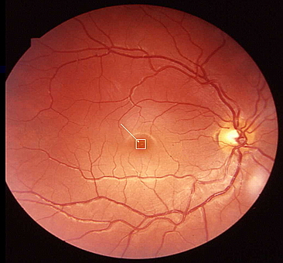
Image of the fundus oculi of a patient affected with solar retinopathy after having observed a solar eclipse through a non-exposed film (a filter absolutely inadequate for the protection of the eye!). It is evident in the white frame the intraretinal macular edema caused by the solar radiation.

Despite all the information campaigns released by the media, in relation with a solar eclipses cases of solar retinopathy are regularly reported. In most cases they are provoked by the use of filters that proved inadequate to block UV radiation.

Solar retinopathy symptoms are the permanent perception of a central scotoma in the visual field (black stain), and eritrosis (red vision).

Luckily, in 90% of cases, such problems tend to recess in a time range spanning from 2 weeks and 6 months. Because of the pathogenic mechanism involved, an early treatment may be recommended with antioxidants and anti-inflammatory (group A,C, and E vitamins, corticosteroids).

Eye Safety

In sum, the Sun can be dangerous for the eye, particularly for young individuals, whose crystalline lens is more transparent. Always use filters that have been specially tested for the direct observation of the Sun (UV and IR radiation) and try to get used to protect your eyes with sunglasses, starting from a very early age.

dr. Fulvio Parentin
Children's Hospital "Burlo Garofolo" Trieste
Department of Ophthalmology

