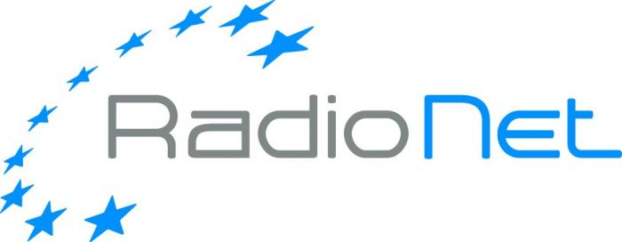

Request for RadioNet support for
Short Term Missions (STM)

- Call text
- The application form to be used
RadioNet support for Short Term Missions
Call

RadioNet is an EC funded project, which brings together the premier radio astronomical facilities in Europe to serve a growing research community across all of Europe and beyond. The EC funds in this programme are dedicated among others to support the mobility in order to reinforce the contacts between the different groups: astronomers, engineers and industry. This will allow early career researchers to establish international, diverse collaboration. On the long perspective it will lay a foundation for the sustainability of the present and future infrastructures.
The exchange programme (Short Term Missions – STM) is open not only to the RadioNet partners, but also to institutes elsewhere. However, the visit must take place at the RadioNet beneficiaries. The RadioNet will support travel and accommodation costs of maximum 900EUR per week and 1500EUR per mission. Each visit will be documented in an assessment report following a report template, clearly specifying the added value for the RadioNet community. You are welcome to contact the STM activity leader – Dr. Reinhard Keller (rkeller@mpifr.de) for more information about the RadioNet exchange programme.

We are inviting early career researchers from astronomy and industry to respond to the call using the application form (including a CV and the invitation of the host institution). The applicants are encouraged to contact the host institution in advance to produce the short description of work in liaison with them.

Please send the duly filled in application form as PDF file to RadioNet@mpifr.de
Deadline: February 15th, 2017, 5pm

The duly submitted applications will be evaluated by the Selection Committee.The results will be announced within 3 weeks after the submission deadline. The Short Training Mission has to start, if approved, during the 6-month period following the approval of application, so that the applicant has some time to organize the visit. There is a 3-month time limit after the event for claiming the expenses, upon completion of the assessment report.
Do not hesitate to contact the RadioNet office for any assistance.
Sincerely,
RadioNet Management (RadioNet@mpifr.de)

Funding principles:
- Cost must be actually incurred in connection with the RadioNet action and necessary for its implementation
- Cost must be identifiable and verifiable, in particular recorded in the accounts in accordance with the accounting standards. Cost must comply with the applicable national law on taxes, labour and social security
- Travel costs and related subsistence allowances (including related duties, taxes and charges such as non-deductible value added tax (VAT) paid by the beneficiary) are eligible if they are in line with the beneficiary’s usual practices on travel.
- Cost must be reasonable, justified and must comply with the principle of sound financial management, in particular regarding economy and efficiency (i.e. in line with a good housekeeping practice when spending public money, avoiding monetary excesses).
‘Economy’ means minimising the costs of resources used for an activity (input), while maximising quality; ‘efficiency’ is the relationship between outputs and the resources used to produce them.

Examples:
1. The beneficiary may NOT increase the remuneration of its personnel, upgrade its travel policy or its purchasing rules because of the European Commission support.
2. Entertainment or hospitality expenses (including gifts, special meals and dinners) are in principle not eligible.
3. Tips, which are not obligatory, are not eligible. By contrast, in some countries the invoice of the restaurant includes a certain mandatory amount as payment for the ‘service’. In this case, the amount may be considered eligible — if the other eligibility conditions are fulfilled.
4. Cost of cancelled trips/events cannot be reimbursed.

Eligibility for funding:
Researchers throughout the world can participate in the Horizon 2020 projects - though they are not always eligible for H2020 funding. Regarding funding, we can distinguish between countries that are automatically eligible for funding and those that are not. For more information click here: http://ec.europa.eu/research/participants/docs/h2020-funding-guide/cross-cutting-issues/international-cooperation_en.htm

RadioNet support for Short Term Missions
Application form
STM Information
Applicant ‘s Name
Applicant’s Affiliation
Host Institute | Insert the address of the host institute and the information of the contact person (name, e-mail, telephone). Add the copy of the invitation letter (e-mail)
Date of the STM | Expected start and end date
Total Cost of STM
Other sources of funding | Please specify the other sources of funding
Request (max. 2,5 pages)
Topic | Please describe briefly the topic of the proposed event coordinated with the hosting institute.  Address the relevance of the event for the scientific and/or the technical community within the context of RadioNet, promotion of results of the RadioNet activities.
Proposed work | Describe briefly the work proposed in cooperation with the hosting institute (1/2 page max).
Cross-disciplinary | Please specify the cross-disciplinary fertilization; especially transfer of scientific knowledge to the next generation of scientists and engineers, e.g. knowledge transfer between engineers, scientists and industry and to the less experienced institutes.
Impact | Please explain the impact on collaboration of European radio astronomy engineers with industry and a wider community (scientific, technical, industry).
Curriculum Vitae | Including 3 most important publications

For more information about the RadioNet exchange programme please contact the STM activity leader – Dr. Reinhard Keller (rkeller@mpifr.de).

