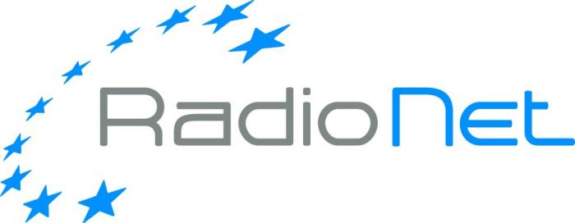

Request for RadioNet support for
engineering events

- Call text
- The application form to be used
RadioNet support for engineering events
Call

RadioNet is an EC funded project, which brings together the premier radio astronomical facilities in Europe to serve a growing research community across all of Europe and beyond. The EC funds in this programme are dedicated among others to foster dialogue between scientists and engineers and to strengthen the collaboration of European radio astronomy engineers with industry. RadioNet´s aim is to bring the European radio astronomy engineering results and expertise to the attention of the broader engineering community. On the long perspective it will lay a foundation for the sustainability of the present and future infrastructures.

We are inviting organisers of engineering events (e.g. conferences, workshops) to respond to the call using the application form. Especially the events focussing on the most effective promotion of the results of the RadioNet activities are welcome. Additionally, we would like to encourage events aiming at the exchange of ideas and the development of new directions – events aiming at attracting the interest of researchers and industrial engineers in related fields to collaborate in the development of radio astronomy as well as industry applications, with the aim to transfer knowledge in both directions. It is important to note that this call is open not only to the project partners but also to institutions elsewhere. However, the event proposed has to have a clear impact on the RadioNet community. You are welcome to contact the Dissemination activity leader – Dr. Reinhard Keller (rkeller@mpifr.de) for more information about the RadioNet technical dissemination programme.

Funding will be provided to support the local cost for organization as well as travel and accommodation costs for attendees (see the funding principles).

Please send the duly filled in application form as PDF file to RadioNet@mpifr.de
Deadline: February 15th, 2017, 5pm

The duly submitted applications will be evaluated by the Selection Committee. The results will be announced within 3 weeks after the submission deadline.
The approved event has to take place during a 12-month period following the approval of application. The event organizers and supported participants are expected to acknowledge the RadioNet support at all advertisement media. The event organizer must provide an assessment report within one (1) month after the event. Additionally, the event organizers are expected to provide the RadioNet Management with the talks/presentations as PDF files. They will be published on the RadioNet wiki pages, if not in conflict with IPR. There is a 3-month time limit after the event for claiming the expenses and upon the submission of the assessment report.
Do not hesitate to contact the RadioNet office for any assistance.

Sincerely,

RadioNet Management (RadioNet@mpifr.de)

Funding principles:
- Cost must be actually incurred in connection with the RadioNet action and necessary for its implementation
- Cost must be identifiable and verifiable, in particular recorded in the accounts in accordance with the accounting standards. Cost must comply with the applicable national law on taxes, labour and social security
- Travel costs and related subsistence allowances (including related duties, taxes and charges such as non-deductible value added tax (VAT) paid by the beneficiary) are eligible if they are in line with the beneficiary’s usual practices on travel.
- Cost must be reasonable, justified and must comply with the principle of sound financial management, in particular regarding economy and efficiency (i.e. in line with a good housekeeping practice when spending public money, avoiding monetary excesses).
‘Economy’ means minimising the costs of resources used for an activity (input), while maximising quality; ‘efficiency’ is the relationship between outputs and the resources used to produce them.

Examples:
1. The beneficiary may NOT increase the remuneration of its personnel, upgrade its travel policy or its purchasing rules because of the European Commission support.
2. Entertainment or hospitality expenses (including gifts, special meals and dinners) are in principle not eligible.
3. Tips, which are not obligatory, are not eligible. By contrast, in some countries the invoice of the restaurant includes a certain mandatory amount as payment for the ‘service’. In this case, the amount may be considered eligible — if the other eligibility conditions are fulfilled.
4. Cost of cancelled trips/events cannot be reimbursed.

Eligibility for funding:
Researchers throughout the world can participate in the Horizon 2020 projects - though they are not always eligible for H2020 funding. Regarding funding, we can distinguish between countries that are automatically eligible for funding and those that are not. For more information click here: http://ec.europa.eu/research/participants/docs/h2020-funding-guide/cross-cutting-issues/international-cooperation_en.htm

RadioNet support for engineering events
Application form
Event Information
Event Title
Event Place
Event Organiser
Event Date
No. of participants
Total event cost
Other sources of funding | Please specify the other sources of funding and their level
REQUEST (max. 2,5 pages)
Requested contribution [EURO] | Please specify the level of the requested RadioNet support [EURO]
Use of the RadioNet contribution | Please specify in details the use of the RadioNet support, indicating the expenses (e.g. who, how much, for what, selection criteria) and keep in mind the goals of the RadioNet. Specify how you will address the ethical aspects.
Topic | Please describe briefly the topic of the proposed event coordinated with the hosting institute.  Address the relevance of the event for the scientific and/or the technical community within the context of RadioNet, promotion of results of the RadioNet activities.
Cross-disciplinary | Please specify the cross-disciplinary fertilization; especially the transfer of scientific knowledge to the next generation of scientists and engineers, e.g. knowledge transfer between engineers, scientists and industry and to the less experienced institutes.
Impact | Please explain the impact of the event on the collaboration of European radio astronomy engineers with industry and a wider community (scientific, technical, industry).
Ethics | Please specify how you will address the ethic issues (e.g. gender, ethnic)

For more information about the RadioNet technical dissemination programme please contact the Dissemination activity leader – Dr. Reinhard Keller (rkeller@mpifr.de)

