 | EUROPEAN SOUTHERN OBSERVATORY  Organisation Européenne pour des Recherches Astronomiques dans l’Hémisphère Austral  Europäische Organisation für astronomische Forschung in der südlichen Hemisphäre
ESO -- European Southern Observatory -- Library -- Karl-Schwarzschild-Straße 2 -- D-85748 Garching bei München
Tel.: +49-89 32006-280 -- Fax: +49-89 3202362 -- Email: esolib@eso.org -- WWW: http://www.eso.org/libraries/

Presenter
Address

January 5, 2006

Dear XXX,

It is a pleasure to formally invite you to attend the conference “Library and Information Services in Astronomy V (LISA V)”, to be held in Cambridge, MA, USA, from June 18-21, 2006. The conference will be co-hosted by the libraries of the Harvard-Smithsonian Center for Astrophysics and the Massachusetts Institute of Technology (see http://www.cfa.harvard.edu/library/lisa/).

LISA V will cover a wide variety of topics centered on the theme: Common Challenges, Uncommon Solutions. The program includes the following sessions:

- Libraries and the Virtual Observatory
- Citation Analysis for Astronomy
- The E-Journal Swamp and the Changing Publishing Sector
- History of Astronomy and Astronomical Archives
- Open Access
- Beyond the ADS and Google
- The Creative Librarian

We are sure that your presentation, “XXX”, will enrich the program. The event will offer a great opportunity for you to interact with your international colleagues, to learn from presentations at the meeting and to share your own knowledge with other conference attendees, and to extend your cooperative links with the astrophysical community.

We look forward to seeing you in Cambridge in June.

Sincerely yours,
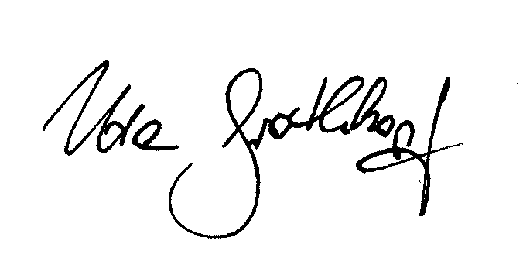
Uta Grothkopf
Co-Chair of the LISA V Scientific Organizing Committee
esolib@eso.org

