CIAO System Tests procedures

- Introduction / Legend

This memo contains the procedure to follow to refine the alignment of a Ciao unit once the cryostat mounted on the warn optical tower.
Each chapter describes a step that should be followed in chronological order, and gives an indication of the duration required.
In Bold font are highlighted names of files, folders, ICS functions, templates and Matlab routines.
In green are indicated the name of reference set of data that can be find in a folder intended to be distributed together with this memo.
In each chapter the procedure to follow is given in black text, while inserts in purple describe briefly the workings of the templates and Matlab reduction routines, although sometimes the distinction may appear fuzzy. More details on those will be provided in the documents in preparation ‘WFS Template Manual VLT-MAN-GRA-15881-5115’ and ‘Methods and Algorithms’ respectively.
Within those inserts, text in black and red is given as example directly as displayed in Matlab.

- Prerequisites

- Cryostat aligned independently --> Field Lens recommended position known (fldlX, fldlY).
- Ciao warm part aligned (with IR camera) --> Parabola focus set and tip-tilt known (pmtip, pmtil)
- Cryostat mounted on warm part.
- Test bench aligned including spherical mirror to simulate the correct UT (Heidelberg). Pupil size measured.
- Warm part aligned to Test bench (Heidelberg) or Coude focus (VLT) --> AOMS position known (msel)

Available templates (with prologue) in /diska/data/CIAO/INS_ROOT/SYSTEM/COMMON / TEMPLATES/OBD/ENGINEERING/:
- CIAO_AOTransferFunction
- CIAO_Anamorphose
- CIAO_CheckCentroids
- CIAO_CheckFoV
- CIAO_FieldLensLinearity
- CIAO_HODMConjugation
- CIAO_IMTracking
- CIAO_ParabolaLinearity
- CIAO_RecordData
- CIAO_SetParabolaRefPos
- CIAO_SetRefSlopes
- CIAO_SpiralSearch
- CIAO_WaitPupilTraking
See definitions in WFS Template Manual VLT-MAN-GRA-15881-5115.

- Executive Summary of procedures, templates and analysis of their results

The table below is an executive summary of the Procedures list (with duration), Templates and Routines detailed in the following of the document.

Procedure | Duration | Template | Matlab routine(s) | Remarks
First estimation of Field and Pupil runout | 1h | CIAO_Anamorphose | 02_Anamorphose_Characterisation  13_DerotatorRunout
Derotator alignment matrix measurement | 6h | CIAO_Anamorphose | 02_Anamorphose_Characterisation  13_DerotatorRunout  17_DerotatorAlignmentCalibration
Derotator alignment | 2h | CIAO_Anamorphose  CIAO_SetParabolaRefPos  CIAO_SetRefSlopes | 02_Anamorphose_Characterisation  13_DerotatorRunout
DM conjugation and Parabola focusing | 4h | CIAO_HODMConjugation | 12_Conjugation_DM2LensletArray  PostProcessing.m
FoV checking | 1h | CIAO_CheckFoV | 01_FOV_Verification
Field Lens and parabola linearity | 2h | CIAO_FieldLensLinearity  CIAO_ParabolaLinearity | 06_FieldLens_Characterisation  07_Parabola_Characterisation
DM model building | 30 min + 2h | CIAO_Anamorphose | 02_Anamorphose_Characterisation  04_DM_Characterisation
IM Library building | ~1h | - | 14_MakeIMLibrary
Transfer Functions measurement | 4h | CIAO_AOTransferFunction | 10_AO_Transfer_Functions
Derotator tracking | 4h | CIAO_IMTracking | 15_DerotatorTracking

------------- Templates and Analysis of their results -------------

All templates have be equipped with a prologue, i.e. a standard set of operations that can be applied to set the system in the right state before the template itself runs.

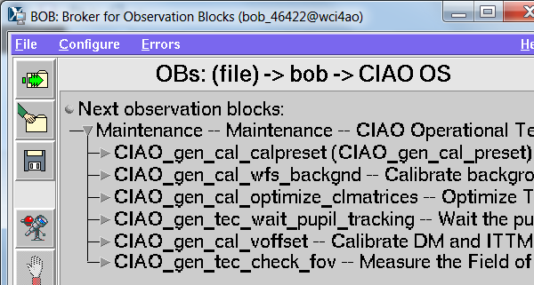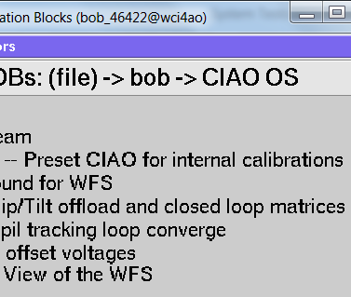

The prologue is composed of the following steps:
- Preset: sets the loop rate, WFS geometry, PRA, SMA and AWF and their gains
- Background: records a WFS background (tilting the TT mount) and applies it
- Optimize Matrices: Computes the HO and TT CMs filtering a given number of modes, sets the KI and KT gains for both loops, and applies them all.
- Wait Pupil tracking: closes the loop and waits for typically 30 seconds that the pupil centring loop converges.
- V offsets: flattens the DM and TTM

------------- End -------------

- Starting point

Duration: 4h

- Spots should be on the WFS with as much as to 2/3 of a pupil shift.
- Turn derotator by 3 steps of 120000 enc to evaluate by eye the amount of runout. If pupil shift always within 2/3 of a pupil and spots stay within sub-apertures, Derotator sensitivity matrix measurement can start. This can also be done by running the template CIAO_CheckFoV and analysing it with 01_FOV_Verification. Reference data: FOV-172330 recorded on 10/02/2016.

------------- Templates and Analysis of their results -------------

CIAO_CheckFoV is used to measure the FoV of the WFS by scanning this FoV (and beyond it) with the TTM and this pattern:
The important input parameters are the filename containing the pattern (cimdatTTMFOVScan, not to be changed) and the number of derotator points at which to take the measurements. The more points, the better the FoV plots. Minimum recommended is 5.

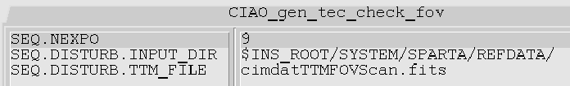

The template results are analysed with 01_FOV_Verification. Possible parameters to change in 01_FOV_Verification / DataAnalysisParameters:
- Space = 'WFS'; %WFS or TTM
‘WFS’ shows the FoV evolution as seen from the WFS, ‘TTM’ as seen from the TTM.

------------- End -------------

- Otherwise the possibilities are:
- Apply manual TT offsets on TT mount or Focus offsets on DM to center the spots in the SAs, or close the loops with only 2 or 3 modes to do so (using DM model not yet calibrated)
- Apply “blind” offsets to the parabola and/or derotator to improve the system alignment, with the help of an optical engineer (Javier) to go in the right direction.

- First estimation of Field and Pupil runout

Duration: 1h

The goal is to make sure the runouts are in the capture range of the analysis routine before starting to record the derotator alignment matrix.

- Run the template CIAO_Anamorphose several times in a raw to verify repeatability. Run it again after untightening the screws of the derotator. Reference data: ANAMORPH-134010, ANAMORPH-142945 (same conditions), ANAMORPH-143800 (after attempts of moving the folding mirror) and ANAMORPH-144638 (after untightening the screws) recorded on 11/02/2016. Then analyse it with 02_Anamorphose_Characterisation and then 13_DerotatorRunout.
This table shows that the results were repeatable enough that we proceeded with the derotator alignment matrix measurement.

ANAMORPH- | Pupil |  |  |  | Field
ANAMORPH- | 0 Theta |  | 2 Theta |  | 0 Theta |  | 2 Theta
ANAMORPH- | x | y | x | y | x | y | x | y
134010 | -1.17 | 0.82 | 0.16 | 0.01 | -0.75 | 1.02 | 0.36 | -0.18
142945 | -1.14 | 0.81 | -0.22 | -0.38 | -0.72 | 1 | 0.68 | -0.08
143800 | -1.13 | 0.82 | -0.19 | -0.4 | -0.74 | 1 | 0.69 | -0.07
144638 | -1.15 | 0.81 | -0.18 | -0.41 | -0.74 | 1.02 | 0.68 | -0.09

------------- Templates and Analysis of their results -------------

CIAO_Anamorphose is used to measure Interaction Matrices for several derotator positions. From this set of IMs can then be estimated the mis-registration at each position and thus the pupil and field runout.
Data is recorded while applying Zonal modulation or white noise.
The important input parameters are the filename containing the pattern (cimdatNoise, not to be changed), the number of modes to truncate when closing the loop to flatten the TTM at each position, and the number of derotator points at which to take the measurements. The more points, the better the runout estimations. Minimum recommended is 5.

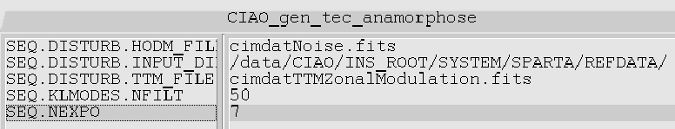

The template results are first analysed with 02_Anamorphose_Characterisation:
- First a rough estimation of the pupil shift is done and the sub-apertures with enough flux selected:
- Then the lag is measured for all sub-apertures and actuators:
- Then IMs are generated based on the measurements and stored in a Matlab structure ‘IMs’ in a subfolder IMs/Demodulated/ of the data folder:

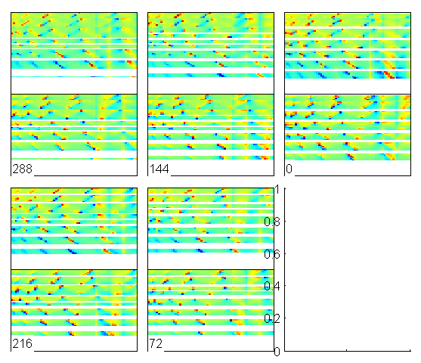

There are no particular parameters to change in 02_Anamorphose_Characterisation / DataAnalysisParameters.

The next step consists in analysing the IMs with 13_DerotatorRunout which will compute the moments of the Field and Pupil runout, and store them in a Matlab structure ‘Runout’ in the data folder:

Possible parameters to change in 13_DerotatorRunout / DataAnalysisParameters:
- ReconstructionMethod = 'Rough'; % Rough or IMModel
‘IMModel’ is more accurate but takes longer to compute.

------------- End -------------

- Derotator alignment matrix measurement

Duration: 6h

The goal is to measure the sensitivity matrix between the 5 axis of the derotator, the 2 of the field lens and the 2 of the parabola and the Field and Pupil runout moments.
Each of the 5 derotator axes can be moved independently and the actual offset applied read-back thanks to position gauges, which are the values to be logged. Note that when moving some of the axes can have an effect on several gauges. If one wants to have signal on one gauge only the others should then be set back to the original values thanks to their dedicated actuator.

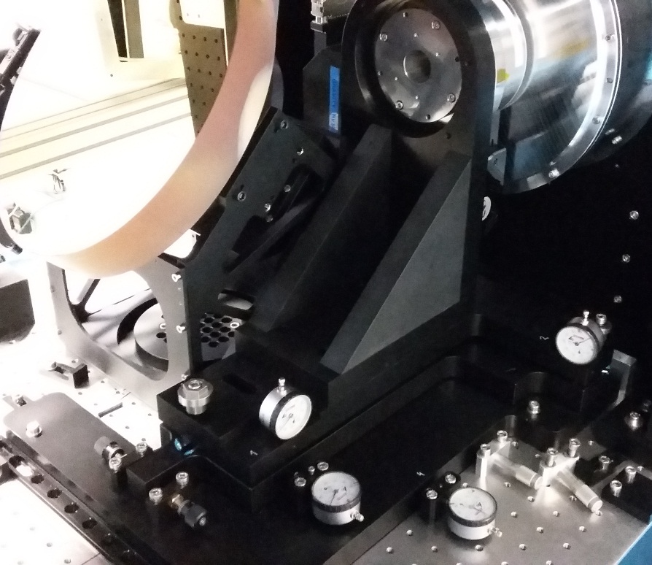
Folding mirror

Cryostat

Gauge #1

Gauge #2

Gauge #3

Gauge #4

Gauge #5

On can thus first proceed by quickly minimizing the runouts by moving some actuators. The Reference Data ANAMORPH-152359 was recorded after moving the gauge #1 of -0.3 mm and the data ANAMORPH-162550 the gauge #4 of +0.2 mm. See the 2 sets of plots below.

The derotator IM is then generated and inverted in several steps:
- Running the template CIAO_Anamorphose for the reference position and offsets of the 5 gauges around that position, as well as the 2 field lens and the 2 parabola axes.
- Logging the recordings in a .CSV file named DerotatorCalibrationLogs.csv and located in the same day directory as the measurements. The contents of the file look like in the following table. Every axis has been actuated once by either 100 or 200 microns or 1500 encoder steps for the parabola, and reference measurements (empty column) were taken at 3 moments. Note that more measurements could be taken for redundancy, including cross-talk of several axes.

Date |  | ANAMORPH-170422 | ANAMORPH-170928 | ANAMORPH-171430 | ANAMORPH-172225 | ANAMORPH-172842 | ANAMORPH-174543 | ANAMORPH-174020 | ANAMORPH-175155 | ANAMORPH-175716 | ANAMORPH-180341 | ANAMORPH-180822 | ANAMORPH-181247
Gauges | 1 |  |  |  | -200
 | 2 |  |  |  |  |  | 100
 | 3 |  |  |  |  | 100
 | 4 |  | -100
 | 5 |  |  | -200
Parabola | X |  |  |  |  |  |  |  |  |  | 1500
 | Y |  |  |  |  |  |  |  |  |  |  | 1500
Field Lens | X |  |  |  |  |  |  |  | 200
 | Y |  |  |  |  |  |  |  |  | -200

- Analyse all the templates’ results first with 02_Anamorphose_Characterisation and then 13_DerotatorRunout to build the database of runouts.
- Then run 17_DerotatorAlignmentCalibration that will build the derotator alignment matrix.
- After visually comparing it to the old one, when prompted to ‘Save the derotator sensitivity matrix?’, answer ‘y’

------------- Templates and Analysis of their results -------------

The routine 17_DerotatorAlignmentCalibration is to be run on a set of data recorded with the CIAO_Anamorphose template and that have already been analysed with 02_Anamorphose_Characterisation and 13_DerotatorRunout, and it also requires the .CVS file named DerotatorCalibrationLogs.csv to be present in the data folder.
It will load the database of runouts, build the derotator alignment matrix, display the comparison with the current one and prompt for updating this IM by default.
This matrix is stored in the Matlab structure ‘DerotGauges2Runout’ in the folder DATABASE\Heidelberg\DerotGauges2Runout\[Date]. Several such folders exist for several IMs, and the one currently in use is specified in the file DATABASE\Heidelberg\DerotGauges2Runout \ Baseline.txt.
There are no particular parameters to change in 17_DerotatorAlignmentCalibration / DataAnalysisParameters.
------------- End -------------

- Derotator alignment

Duration: 2h

The goal is to iteratively minimize the Runouts by displacing the derotator, parabola and field lens. The re-alignment suggestions are provided by the routine 13_DerotatorRunout applied to the data from a CIAO_Anamorphose template after first applying 02_Anamorphose_Characterisation.

One should start with a measurement of runouts with the Field lens at its recommended alignment position. Reference Data: ANAMORPH-181717, without forcing the position of the field lens to the alignment ones (otherwise too large realignments are suggested)
The alignment suggestions are then:
- Gauge #1: -530 um
- Gauge #2: 75 um
- Gauge #3: -75 um
- Gauge #4: 200 um
- Gauge #5: -5 um
- Parabola : 3021 and 2663 steps
- Field Lens : 110 and 165 um
To be added to the current values. The field lens should be left to the alignment values, and a few iterations will take care of minimizing the runouts with the other degrees of freedom. Reference data: ANAMORPH-192304, ANAMORPH-193606.

------------- Templates and Analysis of their results -------------

Applying the routine 13_DerotatorRunout leads to re-alignment suggestions that are then implemented all in different way:
- The displacement of the derotator mount screws to set new gauges values has to be done manually.
- Parabola offsets have to be changed in the file of default Parabola values (which is set at the beginning of almost every template: ciaomgr@wci[UT#]ao> /data/CIAO/INS_ROOT/SYSTEM/COMMON/SETUPFILES/REF/cimcfgOFF-AXIS_POS.ref under the variables INS.PMTIP.ENC and INS.PMTIL.ENC
A template (not equipped with prologue) allows doing that quickly: CIAO_SetParabolaRefPos. Be careful than in the inputs the two axis are sorted alphabetically (Tilt, then Tip), not like in the ICS panel.

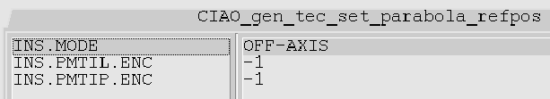

- Field lens offsets are sent using the ICS Control panel and will be applied immediately (we don’t use the concept of reference position for this motor).

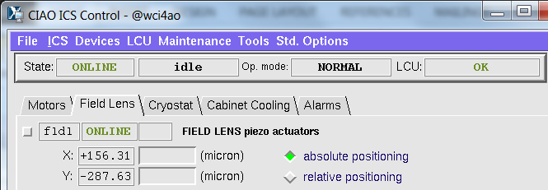

- Reference pixel offsets are set in the CDMS object Acq.DET1.REFSLP, a 136x1 vector if interleaved X and Y reference slopes. It is easily modified using the template (not equipped with prologue) CIAO_SetRefSlopes

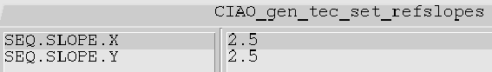

------------- End -------------

At the last iteration the field lens should be moved to the suggested value (should be less than 100 um away) and a final measurement taken. Reference data: ANAMORPH-194158, with small residual runouts and re-alignment suggestions.

======================================
Template: 2016-02-11/ANAMORPH-194158/
--------------------------------------
========
Runouts
--------
Pupil 0 Theta: -0.06 0.05 m
Pupil 2 Theta: 0.05 -0.13 m
Field 0 Theta: 0.03 -0.03 px
Field 2 Theta: 0.55 -0.18 px
===================
Current References
-------------------
Parabola: 1475345 1369165 steps
Field Lens: 200 73 microns
====================
Recommanded Offsets
--------------------
Parabola: 77 -156 steps
Field Lens: -20 15 microns
Ref Pixel Offset: 0.03 -0.03 px
========================
New Reference, Absolute
------------------------
Parabola: 1475422 1369009 steps
Field Lens: 180 88 microns
Ref Pixel Offset: 3.53 3.47 px
=================================
Derotator Realignment Suggestion
---------------------------------
Gauge #1: 30 um
Gauge #2: -5 um
Gauge #3: 5 um
Gauge #4: -10 um
Gauge #5: 5 um
Parabola : -11 and -251 steps
Field Lens : -48 and 39 um

Absolute Values for Parabola and Field Lens
Parabola : 1475334 and 1368914 steps
Field Lens : 152 and 112 um

------------- Templates and Analysis of their results -------------

The use of the routine 13_DerotatorRunout to provide runouts estimations was already described. Additionally, this routine can provide re-alignment suggestions based on the recorded data and on the derotator alignment matrix stored in DATABASE\Heidelberg\DerotGauges2Runout\[Date] \ DerotGauges2Runout.m after running 17_DerotatorAlignmentCalibration (see §4).

For each analysis, the routine will output in the Matlab Command Window such information:

======================================
Template: 2016-02-11/ANAMORPH-181717/ - Name of the analysed data
--------------------------------------
========
Runouts – Estimated values as mentioned in §3
--------
Pupil 0 Theta: -2.02 1.61 m
Pupil 2 Theta: 0.64 0.50 m
Field 0 Theta: -0.50 0.85 px
Field 2 Theta: 0.27 -0.41 px
===================
Current References – extracted from the FITS headers
-------------------
Parabola: 1471860 1366360 steps
Field Lens: 100 -99 microns
====================
Recommanded Offsets – computed from the known sensitivity matrices of the field lens and parabola (conversion of microns or steps into meters or pixels of run-out).
--------------------
Parabola: 798 681 steps
Field Lens: -645 515 microns
Ref Pixel Offset: -0.50 0.85 px
========================
New Reference, Absolute – same as above but in absolute values
------------------------
Parabola: 1472658 1367041 steps
Field Lens: -545 416 microns
Ref Pixel Offset: 3.00 4.35 px
=================================
Derotator Realignment Suggestion – suggested values for field and pupil runout minimization by de-rotator, field lens and parabola realignment. The subset of which should be used in the minimization is defined in 13_DerotatorRunout / DataAnalysisParameters (used if Scale ≠ 0):
- Derotator.Scales.Gauges = 100;
- Derotator.Scales.Parabola = 1000;
- Derotator.Scales.FieldLens = 100;
One can also force some alignment suggestions to pre-defined values by setting the ‘ReachTarget’ parameters to ‘true’ instead of ‘false’.
- Derotator.Gauges.ReachTarget = false;
- Derotator.Parabola.ReachTarget = false;
- Derotator.FieldLens.ReachTarget = true;
This is usually useful when we want to force the field lens to stay close to inputted target position as provided by the cryostat alignment ([100, -100] microns in the example of Ciao#2):
- Derotator.FieldLens.Numbers = [1,2];
- Derotator.FieldLens.Targets = [100 -100];
---------------------------------
Gauge #1: -530 um
Gauge #2: 75 um
Gauge #3: -75 um
Gauge #4: 200 um
Gauge #5: -5 um
Parabola : 3021 and 2663 steps
Field Lens : 110 and 165 um

Absolute Values for Parabola and Field Lens
Parabola : 1474881 and 1369023 steps
Field Lens : 211 and 66 um

------------- End -------------

- DM conjugation and Parabola focusing

Duration: 4h

The only degree of freedom available in the Ciao warm part to change the conjugation of the DM on the lenslet array is the (not motorized) focusing of the parabola. Unfortunately this motion also changes the size of the pupil on the lenslet array as well as the focussing of the WFS.

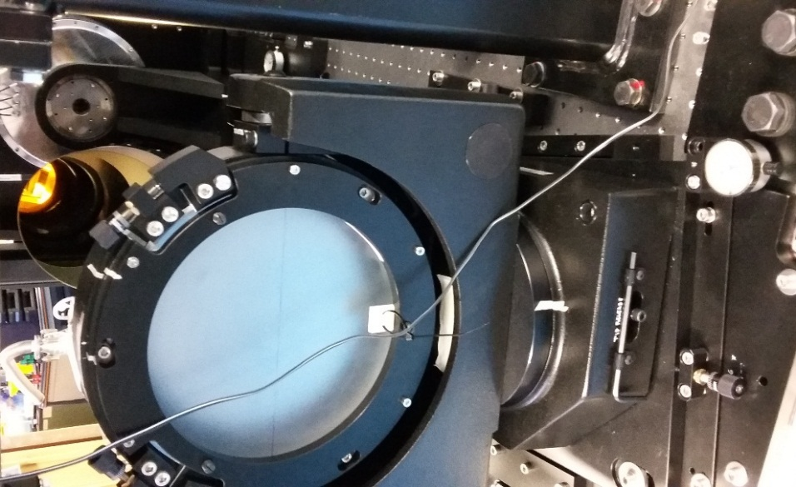
Parabola (back)

Folding Mirror

Cryostat

Parabola Focus gauge

- The pupil conjugation can be measured with the template CIAO_HODMConjugation and analysed with the routine 12_Conjugation_DM2LensletArray for different focus positions of the parabola (see table below), each time compensating for the introduced tilt by tilting the parabola horizontal axis. Then running the PostProcessing.m script provides the optimal focussing value.
- The analysis of the data also gives the pupil size (see table below) but this is not a parameter we are trying to minimize.

Reference data | Parabola focus (mm) | Pupil scale (%)
DM_CONJ-135504 | 0 | 7
DM_CONJ-143021 | 1 | 13
DM_CONJ-152131 | -1.5 | 7
DM_CONJ-153309 | -0.75 | 4

- Finally, shifting the parabola generates a focus on the WFS that will have to be compensated in Closed Loop by the DM or by reference slopes on the WFS, eating up linearity stroke.
Each of the dataset recorded with CIAO_HODMConjugation contains a measurement done at zero reference slopes, including slopes, that can be averaged and projected on Zernike polynomials. The plots below show that the focus was indeed changing linearly with the parabola focus, and that the chosen position to conjugate the pupils does not correspond to the minimized focus. Note that all the data were recorded with the reference DM shape.

------------- Templates and Analysis of their results -------------

CIAO_HODMConjugation is used to measure the conjugation between the pupil at the DM location and the lenslet array. It does so by estimating mis-registrations for different TTM positions. If the DM is conjugated to the DM, a tilt on it will not cause any mis-registration.
The different TTM positions are set by flattening the TTM while closing the loops around different pixel offsets on the WFS: one at the centre and a given number on a circle of given diameter.
The important input parameters are the filename containing the IM method measurement (USER_60), the number of modes to truncate when closing the loop to flatten the TTM at each position, the number of points on the circle (+1 at the centre) and its radius in pixels. The more points, the better the conjugation estimations. Minimum recommended is 5 on a circle of radius 1 pixel where the WFS is still linear.

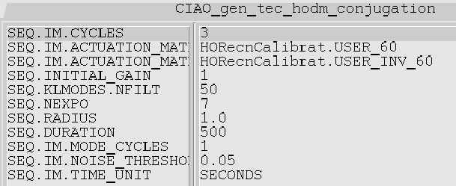

The template results are analysed with 12_Conjugation_DM2LensletArray:
- First a rough estimation of the pupil shift is done and the sub-apertures with enough flux selected:

- Then the mis-registrations are estimated for all positions and subtracted to the reference central one, allowing to determine the pupil scale:
Pupil Scale = 5%
- The system prompts to ‘Give the Parabola position:’ which should be the read-back from the parabola focus gauge in mm (0 for the starting position).
- Its then plots the mis-registrations for all the measurement points (relative to the central one) and stores the results in the Matlab structure DM_CONJ-[meas_time_ID] in the sub-folder DM-LA-ConjugationResults in the folder of the day:

Possible parameter to change in 12_Conjugation_DM2LensletArray / DataAnalysisParameters:
- ReconstructionMethod = 'Rough'; % Rough or IMModel
‘IMModel’ is more accurate but takes longer to compute.

The procedure should be repeated for at least 3 different positions of the parabola focus, each time inputting the focus offset.

Then one should run the file PostProcessing.m present in the folder 12_Conjugation_DM2LensletArray/, which will load all the available mis-registration files in the folder DM-LA-ConjugationResults as well as the inputted parabola focus positions, and superimpose the plots of all of them, allowed to visually determine the best focus:

------------- End -------------

- FoV checking

Duration: 1h

At this point, the alignment of non-motorized parts should be completed. The field lens and parabola tilt can be adjusted by running CIAO_Anamorphose.
To verify the improvement brought by the parabola focusing, one can run the template CIAO_CheckFoV before and after: Reference Data FOV-141759 (left below) and FOV-163232 (right) respectively. On the figure below the white circle represents the size of the limiting 2 arcsec FoV of the AOMS.

- Field Lens and parabola linearity

Duration: 2h

For a proper working of the pupil centering loop in Ciao, the field lens displacement has to be calibrated. This is done by running the template CIAO_FieldLensLinearity and analyzing the results with 06_FieldLens_Characterisation.
The test data for the Field Lens Linearity is FLENS_LIN-165344, and it leads to the following IM:
-2868 116
-134 -2788,
i.e. the field lens should be moved by 2800 um to shift a full pupil diameter.

A tilt of the Parabola produce both tilt and pupil shift as it is locater neither in a focal or pupil plane. Those movements can be calibrated by running the template CIAO_ParabolaLinearity and analyzing the results with 07_Parabola_Characterisation.
The test data for the Parabola Linearity is PARABOLA_LIN-170118, and it leads to the following IMs:
Parabola2M1:
-767 -60
48 -965 x10⁻⁶
Parabola2TTM:
5.4 -41.4
-38.4 -6.5 x10⁻⁶

------------- Templates and Analysis of their results -------------

The templates CIAO_FieldLensLinearity and CIAO_ParabolaLinearity apply a circular pattern of offsets to either the Field Lens of the Parabola axes (+ a measurement at the center) and for each position records an IM in order to estimate mis-registration.
- The important parameters are, besides the IM recording ones which correspond to a modal calibration, the radius of the circle (100 um recommended for the Field Lens and 1000 encoder steps for the parabola).

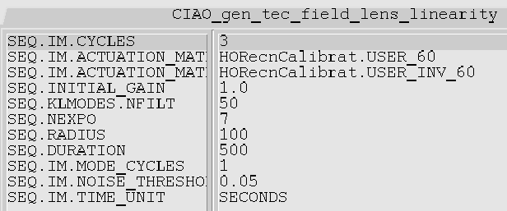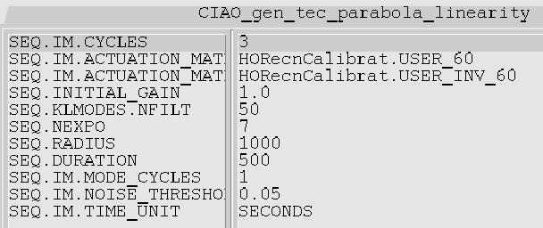

- The Field lens data are analysed by 06_FieldLens_Characterisation which produces the conversion matrix between Field lens microns and full M1 pupil shift. It plots the registration errors and compares the best model with the data, displays the relative change w.r.t the currently used IM and prompts for saving the results. If ‘yes’ is answered the matrix will be updated is DATABASE\Heidelberg\M12FL.m

Change in the result since last time =
1.09 0.03
-0.05 1.09
Sure you want to save the results? (y/n) : y

Note that several consecutive analysis of the same file will not produce exactly the same result because:
- there is a random number generator used in CIAO_IM_OptimizeModel leading to repeatability differences of the order of 1-3%
- The analysis depends on the DM model being used, so the results will differ (by as much as 10%) whether the analysis is performed before or after update the DM model (in §9)

- The Parabola data are analysed by 07_Parabola_Characterisation which produces the conversion matrices between the Parabola tilt (in encoder steps) and full M1 pupil shift, as well as the matrix between parabola tilt (in encoder steps) and TTM commands (in SPARTA units). It plots the registration errors and compares the best model with the data, displays the relative change w.r.t the currently used IM and prompts for saving the results. If ‘yes’ is answered the matrices will be updated is DATABASE\Heidelberg\ Parabola2TTM.m and Parabola2M1.m

Parabola2M1: Change in the result since last time =
1.00 -0.00
0.04 1.19
Sure you want to save the Parabola2M1 results? (y/n) : y
Parabola2TTM: Change in the result since last time =
1.38 0.05
0.04 1.36
Sure you want to save the Parabola2TTM results? (y/n) : y

------------- End -------------

- DM model building

Duration of one measurement : 30 min
Offline processing: between 30 min and 2h depending on the number of iterations (10-30).

The Ciao control relies on the use of synthetic Interaction Matrices, allowing to perform numerical de-rotation. Indeed a set of 180 (to be upgraded to 360) synthetic matrices is stored in SPARTA and loaded and inverted every time the angle of the derotator (in Heidelberg) or of the Azymuth plateform (at the VLT) changes by more than 0.5 degree (to be upgraded to 0.25)

Those 180 or 360 synthetic IMs are calibrated with the measurement of a smaller number of IMs for different derotator (Azymuth) angles, using the template CIAO_Anamorphose, and analysed with 02_Anamorphose_Characterisation and then 04_DM_Characterisation. The reference data for that is ANAMORPH-083422.
Note that it is better to well align the system (with a few iterations of CIAO_Anamorphose with 5 points) before starting this measurement.

It will result in the update in the folder DATABASE\/Heidelberg of matrices describing the system model.

------------- Templates and Analysis of their results -------------

To produce a DM model, one should first run the template CIAO_Anamorphose with a large number of points (27 recommended), analyse the data with 02_Anamorphose_Characterisation to produce the IMs for each position, then stored in the Matlab structure ANAMORPH-[measID]\IMs\Demodulated\IMs.mat.

The next step consists in building the DM model by iterative fitting of those measured IMs. This is done by running 04_DM_Characterisation on the same dataset. The routine first enumerates the parameers used during the data recording, then opens the file DATABASE\Heidelberg\Anamorphose\Parameters.m that contains instrument known parameters and prompts the user to modify it at will and hit return when ready to proceed.

==========================================
2016-02-17T22:11:41
OpticalModel: Processing ANAMORPH-083422/
------------------------------------------
Current UT = Heidelberg
Gains.KG: 0.5 0.5 0.5 0.5 0.5 0.5 0.5 0.5 0.5 0.5 0.5 0.5 0.5 0.5 0.5 0.5 0.5 0.5 0.5 0.5 0.5 0.5 0.5 0.5 0.5 0.5 0.5
Gains.HO_KI: 1 1 1 1 1 1 1 1 1 1 1 1 1 1 1 1 1 1 1 1 1 1 1 1 1 1 1
Gains.HO_KT: 0.001 0.001 0.001 0.001 0.001 0.001 0.001 0.001 0.001 0.001 0.001 0.001 0.001 0.001 0.001 0.001 0.001 0.001 0.001 0.001 0.001 0.001 0.001 0.001 0.001 0.001 0.001
Gains.TT_KI: 1 1 1 1 1 1 1 1 1 1 1 1 1 1 1 1 1 1 1 1 1 1 1 1 1 1 1
Gains.TT_KT: 0.1 0.1 0.1 0.1 0.1 0.1 0.1 0.1 0.1 0.1 0.1 0.1 0.1 0.1 0.1 0.1 0.1 0.1 0.1 0.1 0.1 0.1 0.1 0.1 0.1 0.1 0.1
AWF.Enable: 1 1 1 1 1 1 1 1 1 1 1 1 1 1 1 1 1 1 1 1 1 1 1 1 1 1 1
AWF.Gain: 0.1 0.1 0.1 0.1 0.1 0.1 0.1 0.1 0.1 0.1 0.1 0.1 0.1 0.1 0.1 0.1 0.1 0.1 0.1 0.1 0.1 0.1 0.1 0.1 0.1 0.1 0.1
SMA.Enable: 1 1 1 1 1 1 1 1 1 1 1 1 1 1 1 1 1 1 1 1 1 1 1 1 1 1 1
SMA.Iterations: 2 2 2 2 2 2 2 2 2 2 2 2 2 2 2 2 2 2 2 2 2 2 2 2 2 2 2
SMA.Low: 0.9 0.9 0.9 0.9 0.9 0.9 0.9 0.9 0.9 0.9 0.9 0.9 0.9 0.9 0.9 0.9 0.9 0.9 0.9 0.9 0.9 0.9 0.9 0.9 0.9 0.9 0.9
SMA.High: 1 1 1 1 1 1 1 1 1 1 1 1 1 1 1 1 1 1 1 1 1 1 1 1 1 1 1
PRA.Enable: 1 1 1 1 1 1 1 1 1 1 1 1 1 1 1 1 1 1 1 1 1 1 1 1 1 1 1
PRA.Gain: 0.001 0.001 0.001 0.001 0.001 0.001 0.001 0.001 0.001 0.001 0.001 0.001 0.001 0.001 0.001 0.001 0.001 0.001 0.001 0.001 0.001 0.001 0.001 0.001 0.001 0.001 0.001
NModes: 10 10 10 10 10 10 10 10 10 10 10 10 10 10 10 10 10 10 10 10 10 10 10 10 10 10 10
HOLoop: 0 0 0 0 0 0 0 0 0 0 0 0 0 0 0 0 0 0 0 0 0 0 0 0 0 0 0
TTLoop: 0 0 0 0 0 0 0 0 0 0 0 0 0 0 0 0 0 0 0 0 0 0 0 0 0 0 0
Configuration file in edition. Press return when ready

The routine will first check how much runout was present during this recording (see figure below, left) and then iteratively improve the fitting until the verification matrix is close to Identity (see figure below, center and right for iterations 3 and 10).

An important parameter in the parameter file 04_DM_Characterisation \DataAnalysisParameters.m is Optimization.NIterations that defines the number of iterations for the fitting of the DM model. A minimum number of 10-15 is recommended, and 30 for a slightly more refined result.
At the end of all iterations, when the model is ready, the routine prompts for saving various matrices as listed below (including DM model and System model), to which one should always answer ‘yes’ for saving the models.

Sure you want to save the DM Model? (y/n) : y
DM Model saved to:
D:\jkolb\CIAO\DATABASE\/Heidelberg/DMModel/DMModel.mat
Sure you want to save the Piston Remover Matrix? (y/n) : y
Piston Remover saved in D:\jkolb\CIAO\DATABASE\/Heidelberg/ControlMatrixTools/cimdatPistonRemover.fits
Delta Matrix saved in D:\jkolb\CIAO\DATABASE\/Heidelberg/ControlMatrixTools/cimdatDeltaMacao.fits
TT2HO Matrix saved in D:\jkolb\CIAO\DATABASE\/Heidelberg/ControlMatrixTools/cimdatTT2HO.fits
iTT2HO Matrix saved in D:\jkolb\CIAO\DATABASE\/Heidelberg/ControlMatrixTools/cimdatiTT2HO.fits
HO2TT Matrix saved in D:\jkolb\CIAO\DATABASE\/Heidelberg/ControlMatrixTools/cimdatHO2TT.fits
SubApertureNominalWeights saved in D:\jkolb\CIAO\DATABASE\/Heidelberg/ControlMatrixTools/cimdatSubApertureNominalWeights.fits
Sure you want to save the DM Modal Basis Matrix? (y/n) : y
DM Modal Basis saved in D:\jkolb\CIAO\DATABASE\/Heidelberg/ControlMatrixTools/cimdatDMModalBasis.fits
Sure you want to save the Zernike2DM Matrix? (y/n) : y
Zernike 2 DM saved in D:\jkolb\CIAO\DATABASE\/Heidelberg/ControlMatrixTools/cimdatZernike2DM.fits
Sure you want to save the System Model? (y/n) : y
System Model saved to:
D:\jkolb\CIAO\DATABASE\/Heidelberg/Anamorphose/SystemModel.mat

For each of the (27) measured IMs, the routine will then briefly display the comparison between measured and synthetic as shown below. A difference smaller than 10% should be reached for a good model.
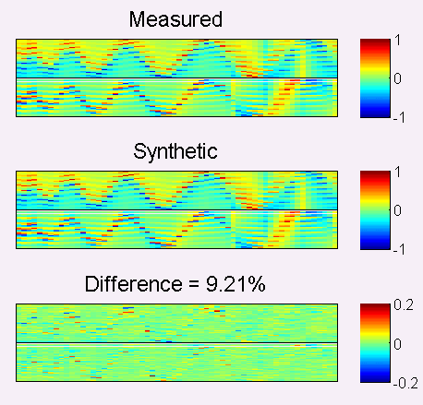

Finally various diagnostics are displayed to confirm the quality of the model, like the electrodes scale factor or the projection of the Influence Fucntions on Zernike polynomials.

------------- End -------------

- IM library building

Duration of offline processing: 5-10 minutes + the time to implement the new IM library as default on SPARTA.

Once the System and DM models built, they can be used to generate IMs for as many derotator (Azymuth) angle as desired, using the routine 14_MakeIMLibrary. The reference data for that is still ANAMORPH-083422.
Matrices will be created in the folders DATABASE\Heidelberg\Matrices\2016-02-16T11-32-52\ and DATABASE\Heidelberg\Matrices\2016-02-16T11-32-52\CDMS\ and the content of the text file DATABASE\Heidelberg\Matrices\Baseline.txt updated to ‘2016-02-16T11-32-52’.
One should then copy the new IM and sensitivity libraries into the SPARTA folder /diska/data/CIAO/INS_ROOT/SYSTEM/COMMON/RTCFILES/REFDATA.

------------- Templates and Analysis of their results -------------

After generating the DM and System model using 04_DM_Characterisation, the libraries of synthetic IMs is built by running 14_MakeIMLibrary. No further input (like the name of the dataset) will be required as this routine will run on the currently available System and DM models stored in DATABASE/Heidelberg.
The routine will display information about those models:

Current UT = Heidelberg
DM Model loaded from:D:\jkolb\CIAO\DATABASE\/Heidelberg/DMModel/DMModel.mat
Template: ANAMORPH-083422/ on 2016-02-16/
Data processing date = 16-Feb-2016 11:07:16
System Model loaded from:D:\jkolb\CIAO\DATABASE\/Heidelberg/Anamorphose/SystemModel.mat
Template: ANAMORPH-083422/ on 2016-02-16/
Data processing date = 16-Feb-2016 11:07:22

In order to save the output matrices in the correct format, one has to make sure to set in the file 14_MakeIMLibrary/SaveMatrices.m the following parameter:

Format = 'AllInOneFile';

Other important input parameters are gathered in the file14_MakeIMLibrary/DataAnalysisParameters.m.
The list of angles for which to compute synthetic IMs for the Derotator or Azymuth depending on the value set in the variable Device below.
Angles.Derotator = 0:179; %[deg]
Angles.Azimuth = 0; %[deg]

The amplitude of perturbations to compute the sensitivities:
Amplitudes.Lateral = 0.1; %[m]
Amplitudes.Angle = 2; %[deg]

The rotating device, either ‘Derotator’ or ‘Azymuth’
Device = 'Derotator';

The matrices that will be updated are:
- The ones in the following folders of DATABASE\Heidelberg\IMs: HO, TT, Zeros, IMSensitivity_X, IMSensitivity_Y, IMSensitivity_Angle
- A new folder will be created in DATABASE\Heidelberg\Matrices with the date and time of the new reference. The file DATABASE\Heidelberg\Matrices\Baseline.txt will be updated with that folder name.

------------- End -------------

- Transfer Functions measurement

Duration: 4h.

------------- Templates and Analysis of their results -------------

Transfer Functions can be recorded for a given number of derotator positions using the template CIAO_AOTransferFunction.
The important input parameters are:

The results are analyzed with 10_AO_Transfer_Functions.

------------- End -------------

- Derotator tracking

Duration: 4h.

CIAO_IMTracking analysed with 15_DerotatorTracking.

------------- Templates and Analysis of their results -------------

------------- End -------------

