20/16 LTAO closed loop with IRLOS in imaging mode
First LTAO closed loop results have been obtained on 14/01, controlling all modes with the LGS WFSs and using IRLOS as an H band imager. The first results through turbulence (baseline seeing and wind speed) are promising as the LTAO correction provides a performance significantly higher than GLAO and single LGS WFS SCAO. Furthermore, scaling the coherent energy from H to R, it seems that the spec of GALACSI NFM can be reached.

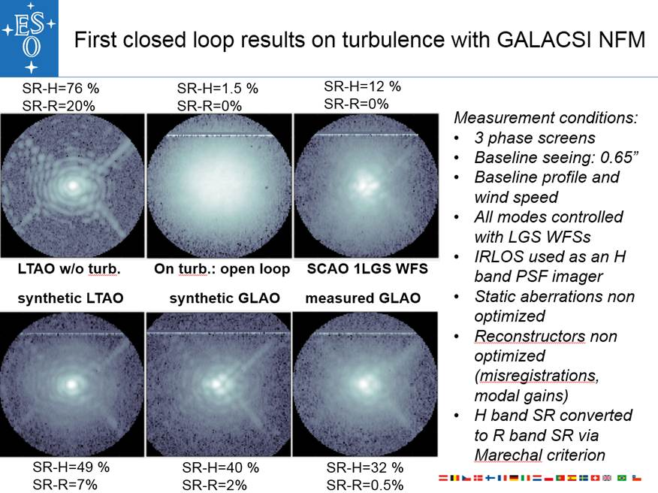
More detailed investigations are performed next. In particular, the influence of the tomographic reconstructor is studied. Let us recall shortly how this reconstructor is built (see section 6):
- 1 MCAO IM is built between 2 atmospheric layers (0 and 9 km) and 4 WFSs located 10” off-axis following the geometry determined by earlier tests.
- The modes applied to generate the IM are Zernikes (1000 at ground, 500 in altitude) whose amplitude have been scaled to generate a maximum of 1 pixel slope when simulating a GLAO IM
- The WFSs are modelled in a very simple fashion:
  - SH geometric model
  - No misregistration
- After computation, the IM is scaled by the inverse of the norm of each Zernike mode used to calibrate it. This is required to be consistent with the atmospheric variance of the Zernike modes used to perform the MAP inversion. However, it may not be a wise choice for tSVD (see later).
- The tomographic process lies in the inversion of this MCAO IM. Two methods have been used:
  - Truncated SVD, removing the most unseen system modes from the control basis, defined as a combination of ground and altitude modes. In this case, we play with the parameter Ntrunk, the number of truncated modes
  - MAP/MMSE reconstructor introducing a regularization term based on the SNR of a given modal basis, the Zernikes in our case. Here we play with the fudge factor called nphot, equivalent to a number of photons, i.e. when nphot is low, many modes are filtered (low modal gain) while many modes are controlled with a significant modal gain when nphot is high
- The same modal basis used to calibrate the MCAO IM is used to calibrate an IM between the two layers and 1 virtual WFS located on axis.
- Multiplying this IM with the previously computed CM allows projecting 4 WFS measurements onto one virtual WFS on axis.
- Finally, we project the slopes measured by the virtual WFS onto DM commands via a simulated SCAO CM, which results from the inversion from a SCAO IM built between the DSM Ifs and the virtual WFS on axis.
- The SCAO CM is computed in the MCM way, that is to say by forcing the truncation of a selected number of KL modes, KL trunk, typically between 300 and 600.
- The main parameters to optimize when building the tomographic recontructor are the following:
  - N layers
  - Layers altitude
  - Nmodes per layer
  - WFSs misregistration
  - Valid subaperures per WFS
  - Normalisation of MCAO IM
  - Nphot or Ntrunk
  - KL trunk for projection on DSM
- So far, only the effect of Nphot and Ntrunk has been investigated while the other parameters have been frozen for the time being.
The way to evaluate each synthetic reconstructor is to measure its closed loop performance on the ASSIST bench. However, it turns out that cosmetic considerations can already allow to discard some options, by comparing the synthetic reconstructor to a measured GLAO one or by looking at the modal basis that each reconstructor allows to control.
For example, one can take a look at the modal gain matrix of the MCAO CM, simply by multiplying the MCAO CM together with the IM. This way, we can evaluate how an input WF mode would be projected to the WFSs and then reconstructed to the WF space.
A few illustrative cases are shown below in the case of MAP. We can see that the MAP CM with nphot =10 looks blurred, which makes sense because only a few modes are controlled. It is visually striking that this reconstructor has no chance to provide optimum performance. When using nphot =200, the resulting CM looks similar to the measured SCAO CM, with an asymmetry left/right in amplitude, which makes sense for a tomographic reconstructor using an off-axis WFS. Finally, nphot=10000 yields the filtering of too few modes and introduces noise in the reconstructor.
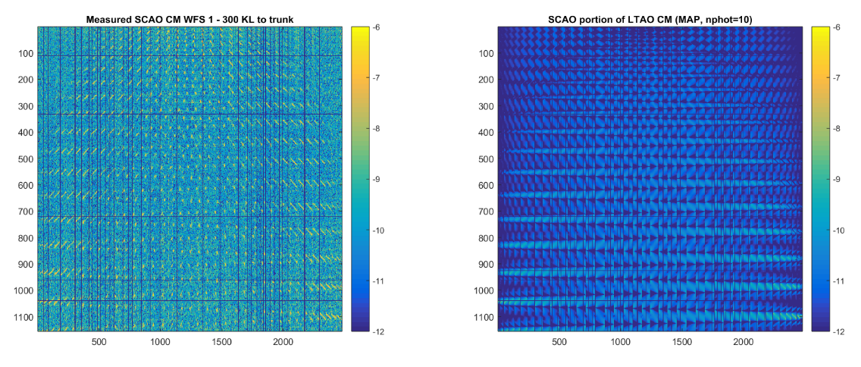
Figure 78: Comparison between measured SCAO to LTAO CM for WFS1, nphot=10
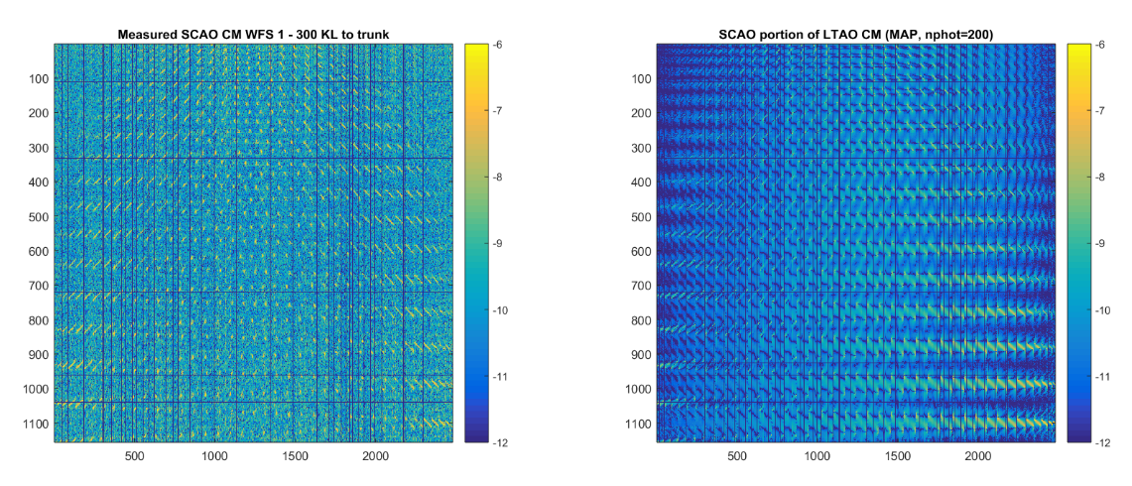
Figure 79: Comparison between measured SCAO to LTAO CM for WFS1, nphot=200
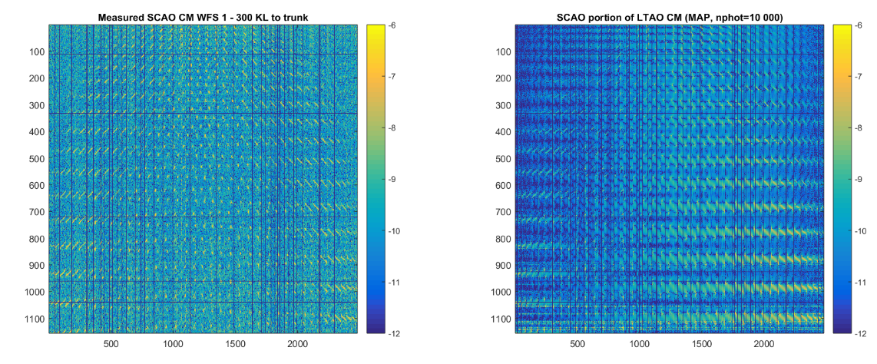
Figure 80: Comparison between measured SCAO to LTAO CM for WFS1, nphot=1e4
But, the modal matrices are probably the most interesting diagnostic tools. On the figure below, one can see that the modal gain matrices are close to diagonal. With a low nphot, the gain is close to 1 for the very low order modes and drops fast for the higher orders. On the other side, when only a few modes are filtered, the gains are homogeneously close to 1 for all modes. However, some coupling between modes can be spotted, especially for the altitude part.
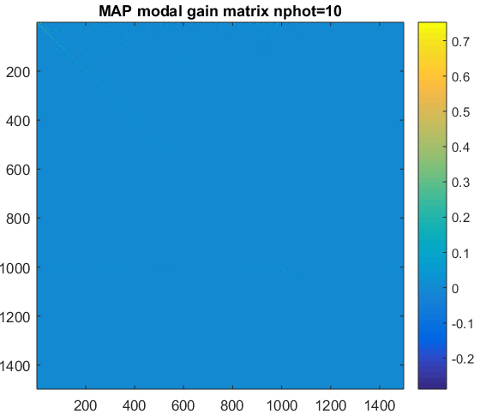 | 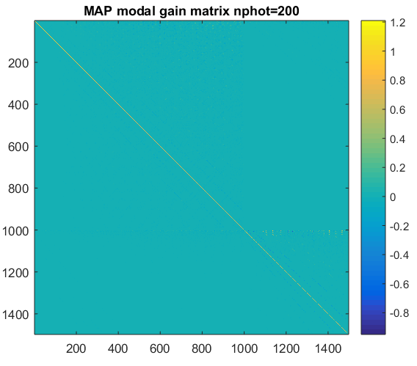 | 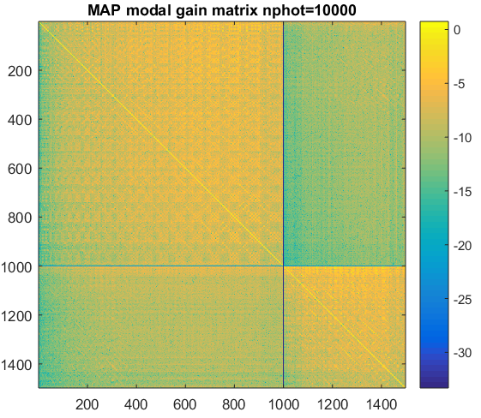
Figure 81: Modal gain matrices for MAP MCAO reconstructors with nphot=10, 200 and 10000. The latter case is in log scale to show the coupling between the modes after reconstruction, especially in altitude.
Looking closer at the diagonal of the modal gain matrix teaches us that with nphot<=10, most of the modes are controlled with a very low gain. With higher nphot, the gains increase towards 1 and become more homogenous across modes. It should be noted that large nphot values yield a high gain for the higher spatial orders in the altitude layer.

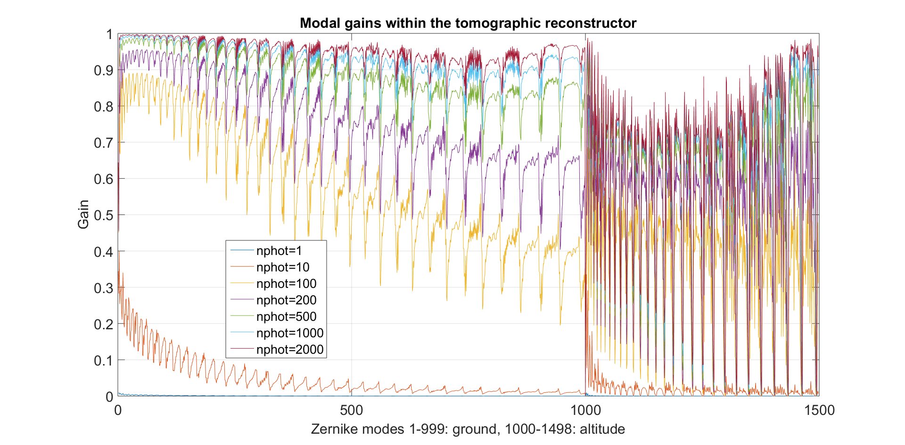
Figure 82: Diagonal of the modal gain matrices in case of MAP
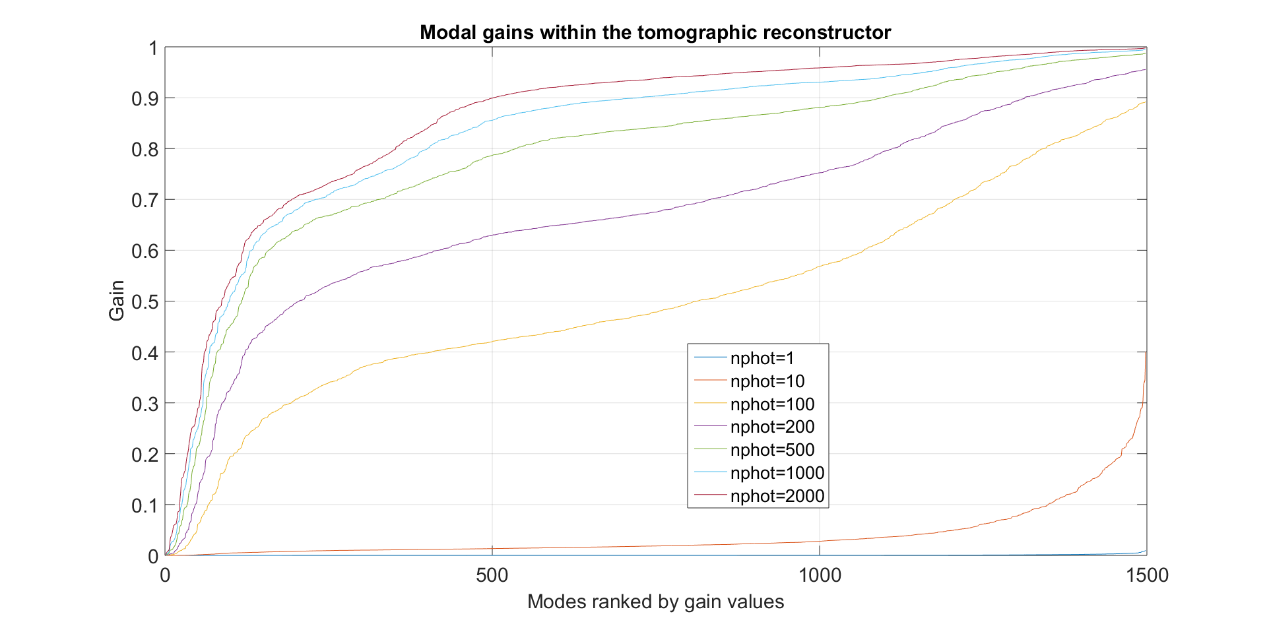
Figure 83: Sorted gains for each nphot, hence random ordering of the modes for each case
When using the tSVD method, it is interesting to look at the singular values of the MCAO IM modes. It looks like no more than 250 system modes should be filtered out to condition the CM properly.
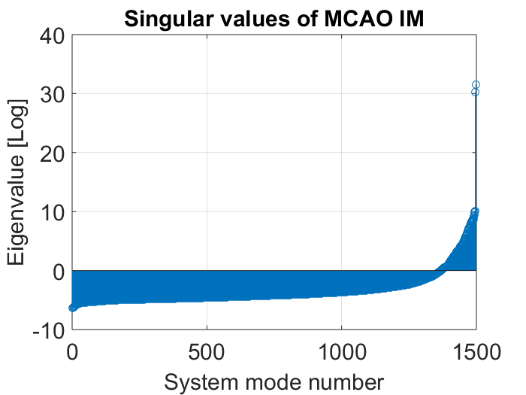
When comparing the LTAO reconstructor built by SVD with different Ntrunks, it appears that for values of Ntrunks larger than 600, the resulting reconstructor becomes noisy.
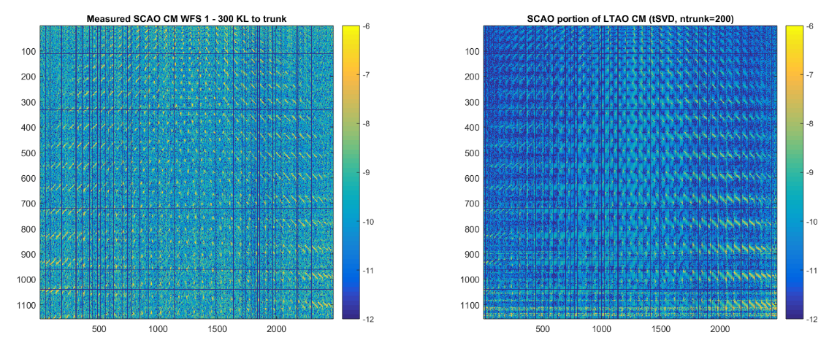
Figure 84: Comparison between measured SCAO to LTAO CM for WFS1, ntrunk=200
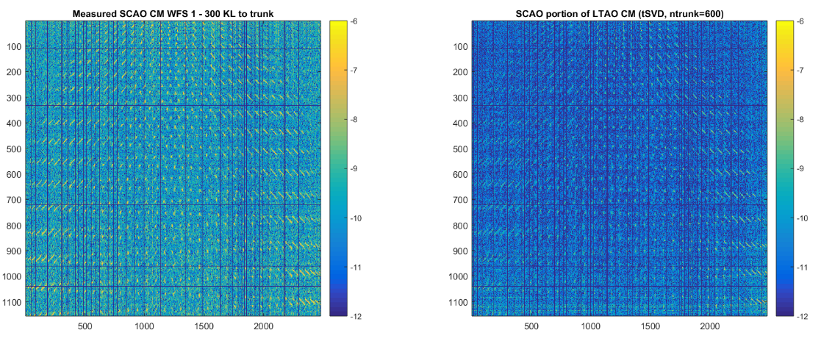
Figure 85: Comparison between measured SCAO to LTAO CM for WFS1, ntrunk=200
Looking at the modal gains for different ntrunk, we can see that the modes of higher spatial order are not filtered and are rather reconstructed wuth a gain close to 1.
Could this have to do with the normalisation of the IM before inversion? To be investigated …
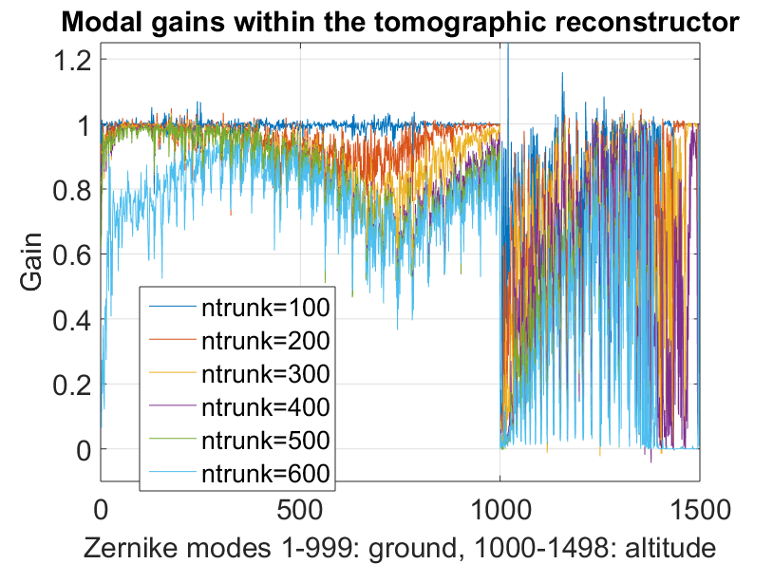
Figure 86: Diagonal of the modal gain matrices in case of SVD
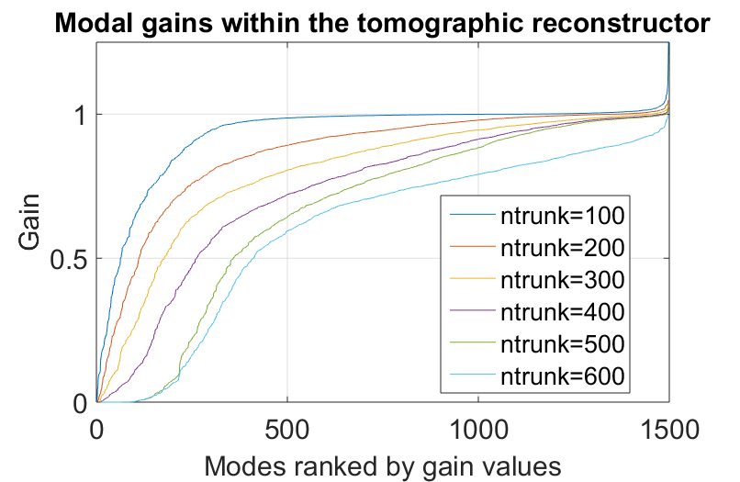
Figure 87: Sorted gains for each ntrunk, hence random ordering of the modes in each case
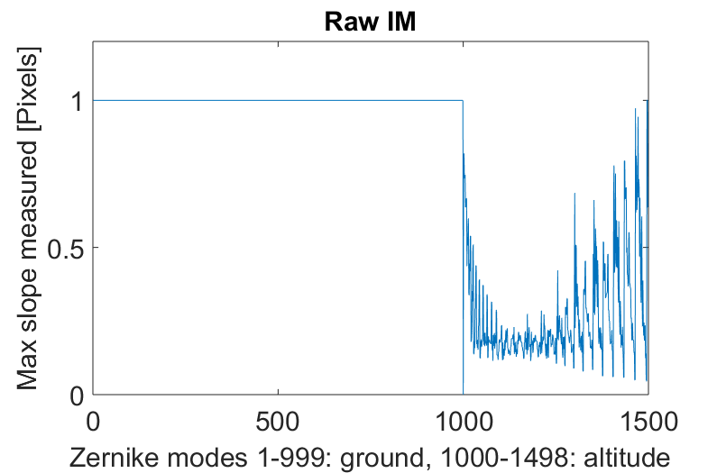
Figure 88: Maximum slope of the MCAO IM for each Zernike mode. The cone effect was not accounted for in altitude where the whole metapupil has been normalized to produce a slope of 1 pixel
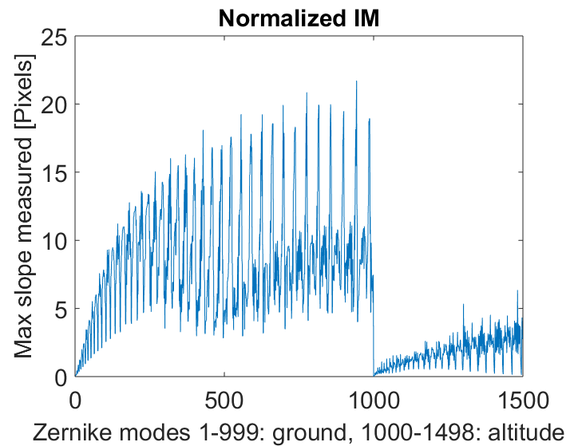
Figure 89: Maximum slope for each mode after normalization by norm of each mode

Finally, the impact of nphot and ntrunk is investigated in closed through the turbulence generator on ASSIST, under the following measurement conditions:
- All modes controlled with LGS
- Small spots, Weight=1, Threshold 15 ADUs, dark subtraction nothing else
- Reference slope as found in GLAO for 650 nm (modal scan2)
- High LGS flux
- Baseline NFM atmosphere case: 3 PS 0.65”
- IRLOS in 140x140 read-out mode (1 Hz) with bad pixels set to 0
- 10 frames of 1s acquired in each case
- IR flux: 55 mA, bright
- Jitters mirrors aligned, 0 reference on DM before closing the loop
The integral gain was scanned with 0 leak factor until the loop would open due to DSM saturation, the leak factor is set to 1%. The scanning is stopped when the loop opens again with a higher integral gain and the leak factor set to 1%. The following cases have been explored:
- MAP nphot=100, trunk=600
  - Ki=[10 20 30 40 50 60 70 80] crash @ 100
  - Kf=[0 0 0 0 0 0 0 0]
- MAP nphot=200, trunk=600
  - Ki=[10 20 30 40]
  - Kf=[0 0 0 0]
- MAP nphot=500, trunk=600
  - Ki=[10 20 30 40 50]
  - Kf=[0 0 1 1 1]
- MAP nphot=1000, trunk=600
  - Ki=[10 20 30 40 50]
  - Kf=[0 0 1 1 1]
- MAP nphot=10, trunk=600
  - Ki=[10 20 30 40 50 60 80 100 120 150]
  - Kf=[0 0 0 0 0 0 0 0 0 0]
- MAP nphot=100, trunk=300
  - Ki=[10 20 30 40 50]
  - Kf=[1 1 1 1 1]
- MAP nphot=100, trunk=300
  - Ki=[10 20 30 40]
  - Kf=[1 1 1 1]
- SVD trunk=500, trunk=600, case 1
  - Ki=[10 20 30 40 50]
  - Kf=[0 0 0 0 0]
- SVD trunk=500, trunk=600, case 2, 2 hours later
  - Ki=[10 20 30 40 50]
  - Kf=[0 0 0 1 1]
- SVD trunk=400, trunk=600
  - Ki=[10 20 30 40 50 60]
  - Kf=[0 0 0 1 1 1]
- SVD trunk=300, trunk=600
  - Ki=[10 20 30 40 50 60]
  - Kf=[0 0 1 1 1 1]
- SVD trunk=200, trunk=600
  - Ki=[10 20 30 40 50]
  - Kf=[0 1 1 1 1]
The following results show that the performance is mostly influenced by the loop bandwidth for a wide range of nphot or ntrunk. The fact to filter less modes (high nphot, low ntrunk) leads to a loop opening at lower Ki values. When more KL modes are applied to the DSM (trunk lower), the performance decreases. The loop does not seem to open because of stability issue but rather due to saturation of the DSM along high spatial frequencies requiring too high force. Several hypothesis could explain this:
- Too many Zernikes are used to calibrate the MCAO IM
- The modal basis is not well chosen. KL may be better on the edges
- The unaccounted misregistration generates waffle modes which are unseen and therefore accumulate. This would explain why a leaky integrator helps. Next step: introduce misregistrations in model and test.
To be optimistic, the following conclusions can be drawn:
- There is a clear margin for improvement as the optimum in correction bandwidth has not been achieved yet
- The obtained results are already good with 54% of absolute strehl ratio @ 1600 nm with turbulence and 86% without, while neither phase diversity, nor vibration tracking have been applied yet
- The reconstructor has been built with a quite crude model (geometric SH, simulated DSM IFs, no misregistration room for improvement
- The case with MAP nphot=100 is promising. The remaining parameter space should be explored around this operating point

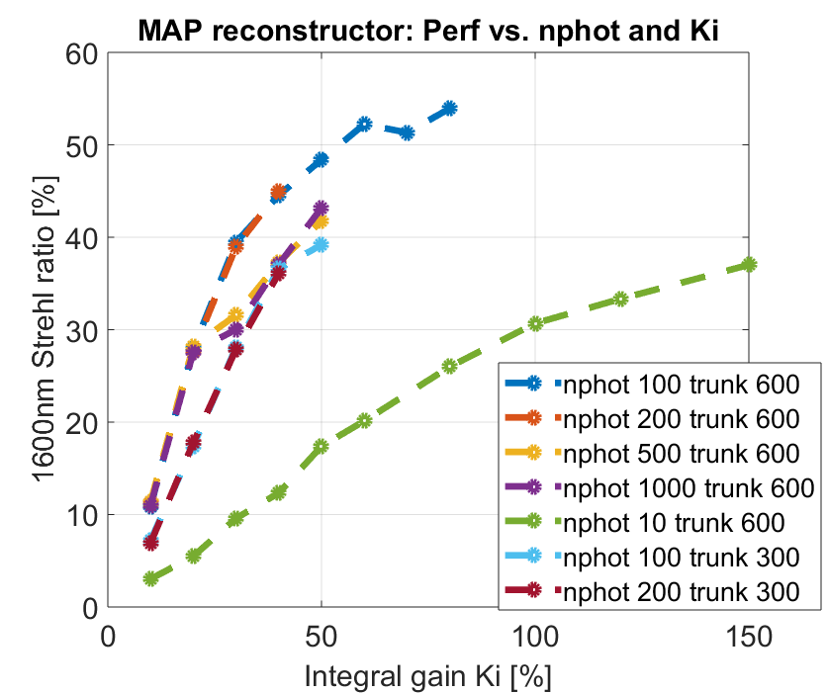
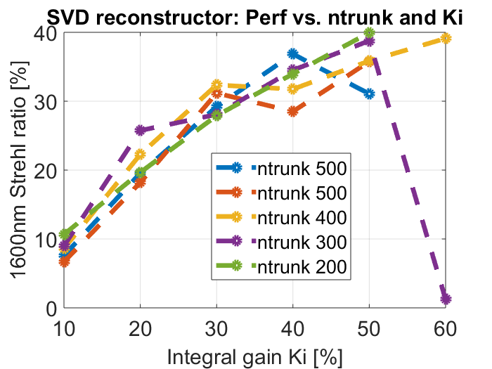
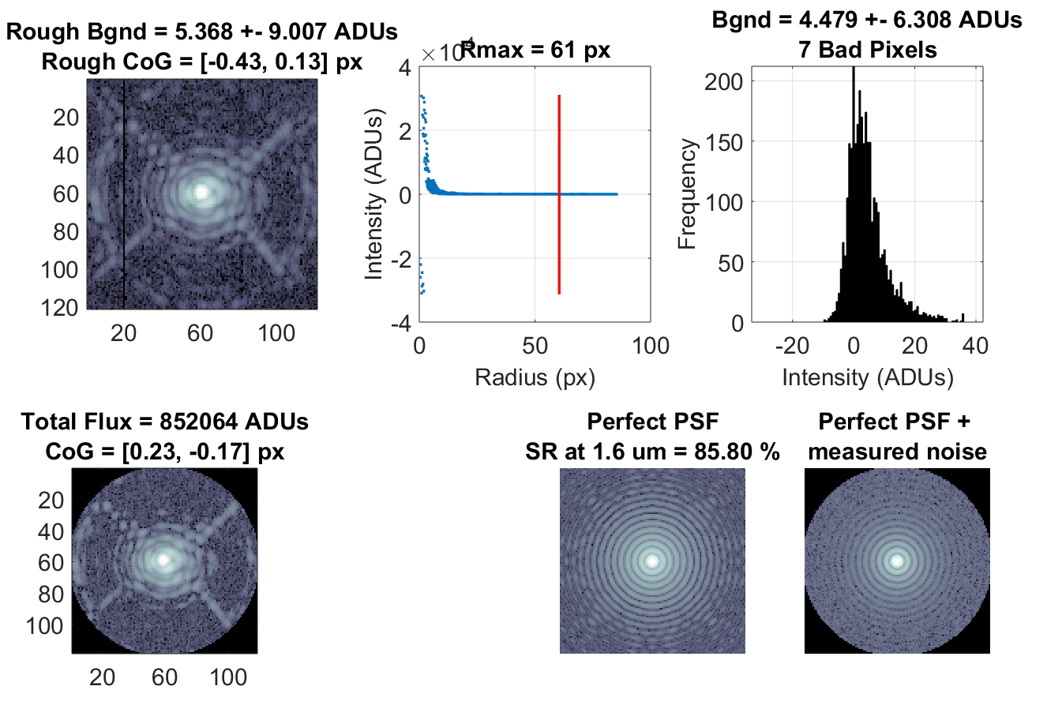
Figure 90: Example of PSF obtained in LTAO closed loop without turbulence- SR(1600nm)=86%
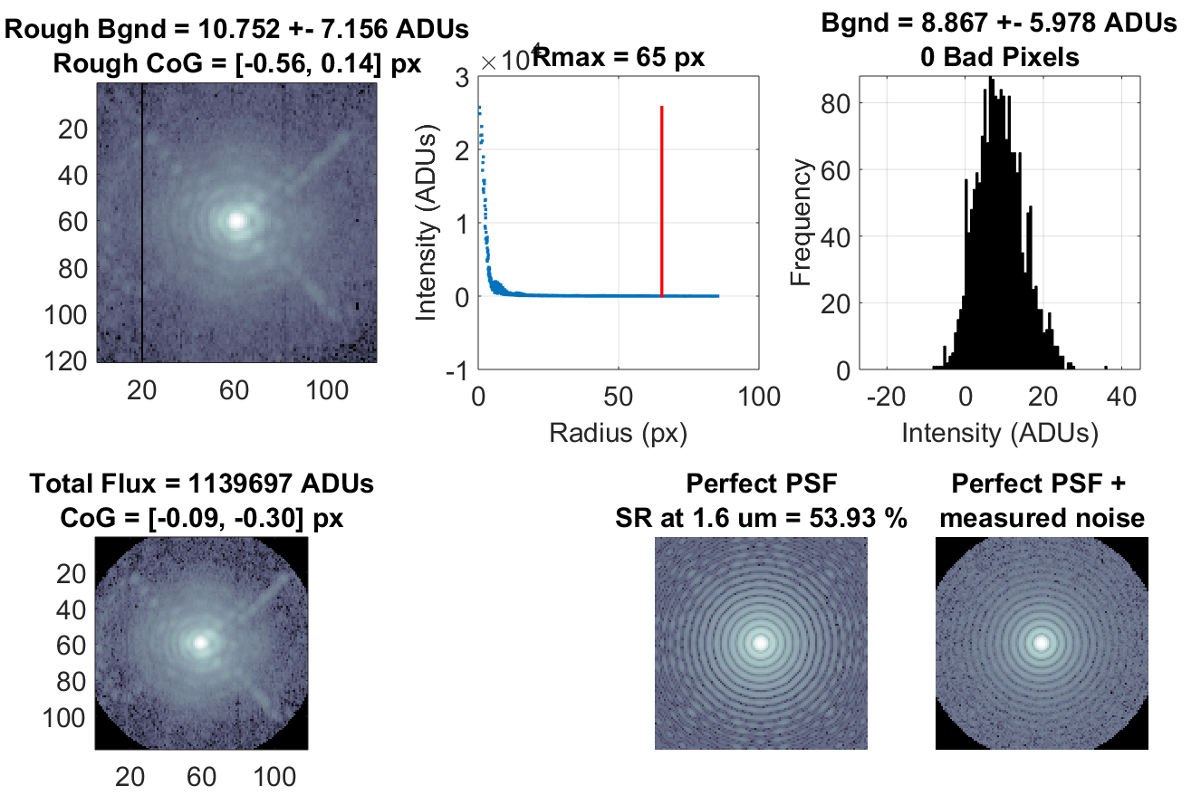
Figure 91: Example of PSF obtained in LTAO closed loop with turbulence- nphot=100, trunk=600, Ki=80, Kf=0,SR(1600nm)=54%

