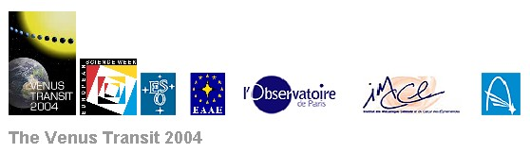

Teachers’ Guide

A short overview for teachers about the transit of Venus, which is a unique and rare astronomical event with many educational aspects related to history, science, technology, etc…

I. How to introduce the Venus Transit

1 The Astronomical Unit and the transit of Venus

2 When does a transit of Venus occur?

3 History of transit observations

4 Exoplanets and transits

II. How to observe the transit of Venus

1 If you have no instrument

2 If you have a pair of binoculars, a refractor or a reflector

III. How to make timings

1 The contact times

2 What do you need to make timings?

3 Your observations and results

IV. Obtaining the Astronomical Unit in four easy steps:

A simplified method for calculating the Astronomical Unit

1 Relation between the Astronomical Unit and the Sun’s diameter
2 Calculating the real distances on the Sun’s surface
3 Calculating real diameter of the Sun
4 Final formula to determine the Astronomical Unit

V. Useful links

I. How to introduce the Venus-Transit

1 The Astronomical Unit and the transit of Venus

Measuring the distance between the Earth and the Sun is an important astronomical objective because all larger distances in the Universe are determined step-by-step starting from it. For example, the distances from the Sun to the planets of the Solar System are expressed as multiples or functions of the Earth-Sun distance. Moreover, the distances to the nearest stars are found using the Annual Parallax method combined with a precise knowledge of the Earth–Sun distance.

On 8 June 2004 there will be a rare astronomical event: a transit of Venus across the face of the Sun. The transit will be seen all across Europe, Africa and Asia and it presents an excellent opportunity for cooperative experiments to measure the Earth–Sun distance, also known as Astronomical Unit.

2 When does a transit of Venus occur?

A transit of Venus occurs when an observer on Earth sees Venus pass across the face of the Sun. Venus orbits the Sun significantly faster than the Earth and passes across the face of the Sun in a straight line at constant speed. A transit occurs when Venus is in inferior conjunction with the Sun – that is, when Venus lies between the Sun and the Earth.

If the plane of the orbit of Venus around the Sun would exactly coincide with the plane of the orbit of the Earth, that is to say the ecliptic plane, there would be a transit at each inferior conjunction, and transits would occur nearly every year. However, this is not the case, as the plane of the orbit of Venus forms an angle of 3.4° with the ecliptic plane. This explains why transits occur only rarely.

In order for Venus to be visible on the disk of the Sun, the ecliptic latitude of Venus must be smaller than half the Sun’s apparent diameter, that is less than 16 minutes of arc (16 / 60°). Venus must therefore be close to a node of its orbit, that is to say near the intersection of its orbital plane and the ecliptic. The angle in the diagram is exaggerated for clarity.

Orbit of Venus

Earth
Orbit of the Earth

Venus
Sun

As a consequence of these conditions, transits occur in pairs 8 years apart, each pair occurring approximately every 120 years. The current pair of transits will take place on 8 June 2004 and 6 June 2012 and the previous pair took place on 9 December 1874 and 6 December 1882.

3 History of transit observations

The transits of 6 June 1761 and 3 June 1769 were marked by major international observational campaigns involving many locations around the world.

The first person to observe a transit of Venus was Jeremiah Horrocks in 1639. He envisaged using the transit to calculate the Earth–Sun distance. Sir Edmund Halley advocated campaigns to observe the transits of 1761 and 1769 and Jean–Nicolas Delisle gathered all the results together. We shall use these results to calculate the Earth–Sun distance and to prepare for observing on 8 June 2004.

Observers were stationed at latitudes as far away from one another as possible, so as to improve the precision of the calculations. A substantial number of observers were needed in case of poor weather conditions and even to be sure that they would reach their destinations in time. The selected places were often in very remote regions and voyages at that time were at risk from storms and warfare, as was the case in the Indian Ocean where England and France were in conflict.

The 1761 transit was notable in being the first occasion that a scientific campaign was coordinated on an international basis. More than 130 different transit expeditions were organised all around the world.

In 1769, there were observers at Pondicherry in Madras, in St Domingo, in Baja California, at Hudson’s Bay in Canada, in Tahiti, at Vardö in Lapland, at Cajanebourg in the Kola Peninsula and at Yakutsk in Siberia. All together there were 151 observers at 77 different locations. All the expeditions had different challenges, some of them were hazardous, and the results didn’t always live up to expectations!

4 Exoplanets and transits

Since the discovery of the first extrasolar planet (1995) by Michel Mayor and Didier Queloz (Observatory of Geneva, Switzerland), more than 120 extrasolar planets have been detected. Most of these discoveries were made by using techniques exploiting the effects of gravity, which are significant in the case of large planets.

The transit of smaller Earth-sized planets in front of a star, similar to the transit of Venus in front of the Sun, produces a drop of the brightness of the star during the transit. With the present-day technologies we are able to detect the relative drop of luminosity of 0.01%, typically produced by an Earth-sized planet. This transit method will probably be the most promising method to discover Earth-sized planets in the future, and may even lead to the discovery of habitable worlds in other solar systems.

II. How to observe the transit of Venus

WARNING! BE CAREFUL!

NEVER LOOK DIRECTLY AT THE SUN WITH UNPROTECTED EYES - THIS MAY CAUSE TOTAL BLINDNESS WITHIN SECONDS!
ALWAYS BE SURE TO USE THE PROPER OPTICAL FILTERS TO PROTECT YOUR EYES.
NEVER LOOK DIRECTLY THROUGH A TELESCOPE TOWARDS THE SUN, EVEN WITH FILTERS (ONLY PROFESSIONALS WELL VERSED IN THESE MATTERS MAY DO SO)!

1 If you have no instrument

Seen from the Earth on 8 June 2004, Venus will subtend an apparent diameter of about one arc minute. Thus our sister planet will be seen easily without an instrument and will be comparable in size to large sunspots. However, without an instrument it is hopeless to try to make valuable useful timings as described in Chapter III. Nevertheless you will be able to observe the phenomena in two different ways:

Direct observations using (cheap) special solar filter glasses. However, you must use these glasses with care: do not scratch the filters and don’t observe the Sun for more than a minute at a time.

You can replace the special glasses with a welder’s dark filter. In this case, use a grade 14 filter (or higher).

The projection method using a simple “camera obscura”. Take a large cardboard box (a shoe box or larger), remove the lid (if any) to see inside the box. Make a small hole with a needle or a nail in the front face of the box and glue a piece of white paper (the screen) on the internal rear face.

Aim the front of the box (with the hole) at the Sun and look inside at the screen ... you should see the solar disk with the big black spot of Venus (hopefully!). If necessary, adjust the size of the hole to get the best possible contrast.

You can also use a large piece of cardboard by cutting a square hole (5x5 mm) and pointing it towards the Sun. Use a sheet of white paper or a bright wall to see the projection of the solar disk. A sharper image can be obtained by using a converging spectacle lens in front of the hole.

You can also buy a cheap instrument specially designed for schools to observe solar eclipses, sunspots, solar rotation and special events like transits of Venus and Mercury (see the paragraph “Useful Links”).

2 If you have a pair of binoculars, a refractor or a reflector

Direct observation of the transit may be done by looking through an optical instrument, but you will need to put a special solar filter in front of the objective(s) if you use binoculars or a refractor. If using a reflector, the filter cannot be put just in front of the mirror, but must be placed over the open end of the telescope tube.

As readymade solar filters are expensive, you can buy a cheap sheet of Astro SolarTM filter and easily construct a simple device to hold the filter at the right place.

If you are going to use binoculars, you can prepare two filters (one for each objective lens) or prepare only one filter to be placed over a lens. But in that case, don’t forget to COVER the other objective with a cap. In the same way, if you are using a refractor or a reflector, it is necessary to cover the finder-scope of the instrument to avoid being burnt accidentally.

BE CAREFUL not to place a solar filter at the eyepiece of a refractor or a reflector! If the filter is near the instrument’s focus, it will receive a lot of solar energy and will become hot. The heating may cause the filter to break suddenly, leaving your eye unprotected and in danger of being permanently damaged and even blinded.

Observing solar and related phenomena through a PROTECTED instrument gives the best images but is inefficient because only one student at a time can look through the instrument. Unless your instrument is equipped with an equatorial mount you will also need to adjust it from time to time to compensate for the Earth’s rotation. If you plan to use an equatorial mount, please follow the instructions packed with the instrument or contact your national node for help.

If you intend to make timings, only one student at a time will be able to do it. A good solution which enables many students to follow the transit as if viewed through the telescope is the use of a webcam mounted on the telescope.

The projection method (the safest method!) is most suitable if you want all the students to see the transit at the same time. In this way you do not need any solar filters.

First, place all the students on the sunward side of the telescope to avoid the danger of looking through the eyepiece directly. Aim the unprotected instrument in the direction of the Sun WITHOUT LOOKING THROUGH THE EYEPIECE OR THE FINDER TELESCOPE, but by looking at the instrument’s shadow and making it as small as possible.

When positioned correctly, the device (binoculars, refractor or reflector) should project an image of the Sun onto a white sheet of paper held on a tripod or on a screen attached to the instrument itself. Never allow anybody to hold a screen in front of the eyepiece! The farther the screen is from the eyepiece, the larger and dimmer the image will be. Try for a 10 cm diameter image by moving the screen and finally sharpen the image by adjusting the position of the eyepiece.

Using this method, a group of students may observe the transit simultaneously and each one can make timings and take pictures of the phenomena. But BE CAREFUL not to let any of the students take a look through the eyepiece. Unless your instrument is equipped with an equatorial mount you will also need to adjust its position in front of the screen from time to time to compensate for the Earth’s rotation. If you are going to use an equatorial mount, please follow the instructions packed with the instrument or contact your national node for help.

III. How to make timings?

If you want to make observations and collect data in order to participate actively in the Europe-wide project of a real time measurement of the Earth-Sun distance, you need to determine the contact times, the moments when Venus is touching the limb of the Sun.

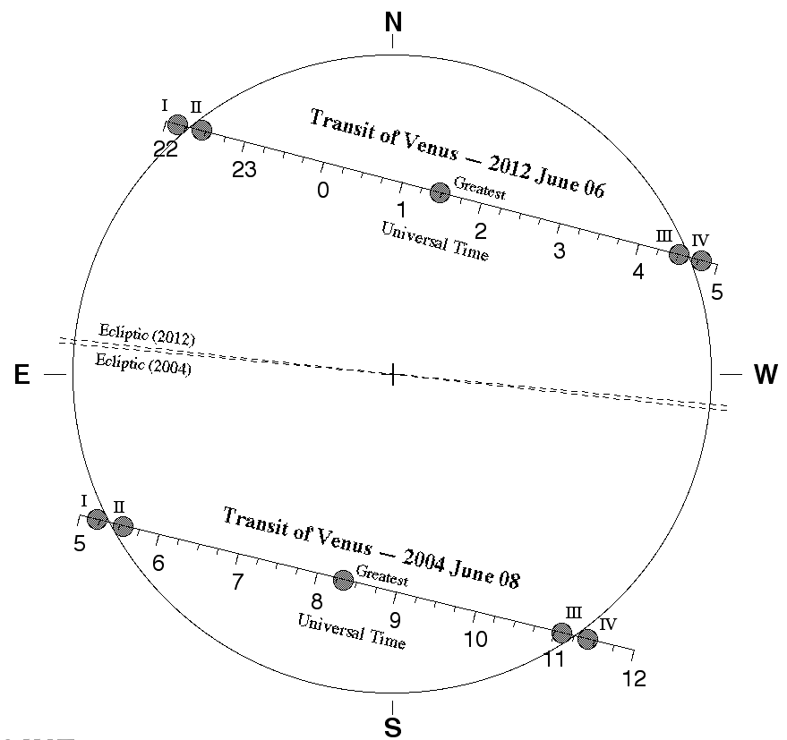

The path of Venus in front of the solar disc and the four “contacts”

1 The contact times

The preceding figure shows the four “contacts” :

I: the moment when Venus' disk first "touches" the solar limb (the "first contact" T1)
II: the moment when Venus' disk has passed the solar limb and is "inside" the solar disk (the "second contact" T2)
III: the moment when Venus' disk first "touches" the other side of the solar limb (the "third contact" T3)
IV: the moment when Venus' disk passes the solar limb (the "fourth/last contact" T4)

2 What do you need to make timings?

- A good timekeeper

Find the difference between Universal Time and your local time and express the transit times for your location in terms of UT. Assistance is available from your VT-2004 National Node or by consulting the VT-2004 web pages. Radio controlled clocks are good timekeepers and easily available. Less reliable are GPS and computer clocks (even when updated by atomic clocks on the web).

- A device to record the times

You will need to determine the contact times to the nearest second. A simple chronometer will do the job but as it is impossible to make very accurate measurements, a simple look at the timekeeping clock will give you an acceptable value. On account of the black drop effect, you may hesitate for some seconds before being sure of the instant of contact. Just subtract one second from the observed time to take into account the reaction and delay times. Don’t forget to express your value in UT.

- Your geographical position

Your latitude and longitude can be determined using a geographical map. An accuracy of 1 arc minute (corresponding to about 2 km) is sufficient. The use of GPS is also recommended.

3 Your observations and results

Ideally, all four contact times should be estimated and expressed in Universal Time (UT). The easiest are T3 and T2 despite the “black drop” effect. T4 is more difficult, but less so than T1, which is almost impossible. But even with only one time, you can participate in the VT-2004 transit campaign. So go to the VT-2004 web page, where you have previously registered, and enter your measured data. The timings may be made by direct observation, by using the projection method or by using webcam images.

A pipeline will also be available at the VT-2004 server where you may submit your images made with digital cameras for processing.

If you want to perform your own calculations to determine the value of the astronomical unit, see the following pages (“Useful Links”).

Approximate contact times for some cities:

CITIES | T1 | T2 | T3 | T4
ATHENS | 5h 20m | 5h 39m | 11h 04m | 11h 23m
BERLIN | 5h 20m | 5h 39m | 11h 04m | 11h 23m
BUCHAREST | 5h 20m | 5h 39m | 11h 04m | 11h 23m
DUBLIN | 5h 20m | 5h 40m | 11h 04m | 11h 24m
HELSINKI | 5h 19m | 5h 39m | 11h 02m | 11h 22m
MADRID | 5h 20m | 5h 40m | 11h 05m | 11h 25m
MOSCOW | 5h 19m | 5h 38m | 11h 02m | 11h 21m
PARIS | 5h 20m | 5h 40m | 11h 05m | 11h 24m
ROME | 5h 20m | 5h 40m | 11h 05m | 11h 24m

IV. Obtaining the Astronomical Unit in four easy steps:

A simplified method for calculating the Astronomical Unit

Introduction

We introduce here the simplest method of calculating the Astronomical Unit from observations of Venus. The goal is to enable students to understand the main idea. We make many simplifications to reduce to a minimum the background knowledge needed. A more accurate version can be found in VT-2004 Educational Sheets 3, 4 or 5 (depending on the level required). This version does not use trigonometry or the concept of parallax.

Students use only the length of the perimeter of the circle, proportions and Kepler’s Third Law.

1 Relation between the Astronomical Unit and the Sun’s diameter

We recall that the Sun, in its apparent relative motion around the Earth, describes a circle of radius a, the Earth-Sun distance (Astronomical Unit). The angular diameter of the Sun is about 0.5 degree (easily measured by students), and the whole circle has 360 degrees. We consider the ratio of the length of the perimeter of the circle of the Sun around the Earth to be 360º and the diameter of the Sun to be 0.5º. If we call D the real diameter of the Sun,

D 2 π a
----- = ---------
  - 360

and the Astronomical Unit a can be obtained if we know the real size of the Sun’s diameter D because

a = 360 D / π (1)

We now need to determine the diameter D from observations of the transit of Venus.

2 Calculating real distances on the Sun’s surface

We now need to consider the situation of the Earth, the Sun and Venus during the transit:

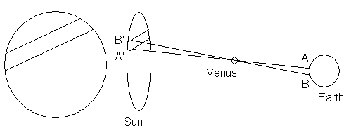

Figure 1

A
B
A′
B′
VENUS
a-d

d
Figure 2
a

We consider the two triangles in Figure 2.

We assume that the transit of Venus is observed from two different places on the Earth’s surface: A and B. To simplify the calculations, we further assume that both A and B are on the same meridian.

In Figure 2, the triangles ABV and A′B′V are similar, so we can consider the proportion (Thales’ Theorem)

A′B′ a-d
------ = ----- (2)
AB d

The value of (a – d)/d may be calculated by means of Kepler’s Third Law saying:

(a – d)³ / a³ = (T_{V})² / (T_{E})²

where T_{V} and T_{E} are the periods of revolution of Venus and of the Earth respectively.

The durations of these periods are T_{V} = 224.7 days and T_{E} = 365.25 days.

Therefore (a – d)³ / a³ = (224.7)² / (365.25)² and this yields:

(a – d)/d = 2.61

Introducing this value into the previous relationship (2),

A′B′ = 2.61 AB (3)

where the distance AB, between the two places A and B on the Earth, is well known. Thus we know the real distance between A′ and B′ on the Sun’s surface.

3 Calculating the real diameter of the Sun

Figure 3

We will use the observations made from two different places. We put on one drawing (Figure 3) the points M and N which are the positions where Venus is seen if we look towards the Sun from A and B on Earth. On this Figure we can then measure the diameter of the Sun Δ and the distance between A′ and B′, that is MN. We introduce the ratio

A′B′ D
------ = -----

MN Δ

(Please note that the real values are A′B′ and D, and the values from the drawing are MN and Δ). From this relationship we calculate the real diameter of the Sun. Indeed we have the measures of Δ and MN from the photography, and we substitute A’B’ as determined in (3).

Δ
D = 2.61 AB -------
MN

4 Final formula to determine the Astronomical Unit

Introducing the value of D into the first formula (1), we can now determine a, the Earth-Sun distance:

939.6 AB Δ
a = ------------------ --------
π MN

using MN and Δ from the drawing (Figure 3) and the real distance AB between the two observing locations. Note that the distance AB is not on the Earth’s surface but on a straight line as can be seen easily from Figures 1 and 2.

V. Useful links:

What you will see on June 8: An animation of VT (VT-2004 Animation A)

Historical observations and travels (VT-2004 Brief InfoSheets Section F)

Exoplanets (VT-2004 Brief InfoSheet E1)

Safety guidelines: (Safety Instructions)

The projection method (VT-2004 Brief InfoSheet B2)

Direct observations using telescopes, camera, webcam (VT-2004 Extended InfoSheet B2)

Simple equipment : Venuscope (http://www.venuscope.com)

Universal time: (VT-2004 Brief InfoSheet B3)

How to participate in the VT-2004 Observing Campaign: (How to participate)

Making your own calculations: (VT-2004 EduSheet 3)

Information for kids: (Kids Area)

Information in your own language, as available at the websites of the VT-2004 National Nodes: (In Your Region and in Your Language)

More animations about Venus transit (VT-2004 Animations )

Power point presentation about Venus transit (R. Wielinga PPT)

Visibilty of sunspots: (http://bass2000.obspm.fr/solar_web.php)

