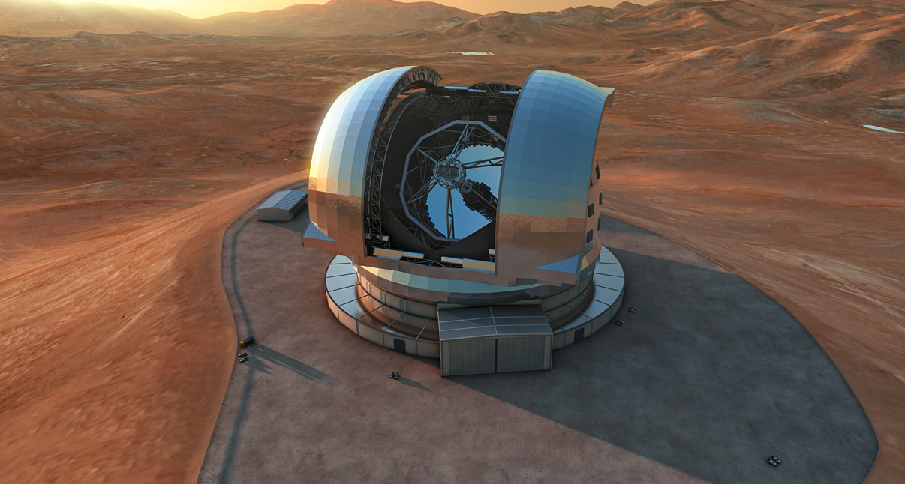

Poland@ESO 2015

July 3rd, 9:00-17:00
Nicolaus Copernicus Astronomical Centre
Warsaw
18, Bartycka str.

Programme
09:00-9:15 Registrations and coffee
09:15-9:30 | Welcome  Prof. Wlodzislaw Duch  Undersecretary of State  Ministry of Science and Higher Education
09:00-9:30 | Introduction to ESO  Patrick Geeraert, Director of Administration
10:00-10:45 | Presentation of the Directorate of Engineering  Gerald Hechenblaikner, Deputy Director of Engineering
10:45-11.30 | E-ELT Project and Opportunities  Mark Casali, Head of E-ELT Instrumentation & Head of Technology Development
11:30-12:15 | Industrial involvement and procurement processes  Arnout Tromp, Head of Contracts and Procurement
12:15-13:15 | Buffet lunch
13:15-17:00 | Short presentations by the Polish companies, followed by possible “one-to-one” short meetings (not longer than 15 min/each) between ESO representatives and interested Polish companies

