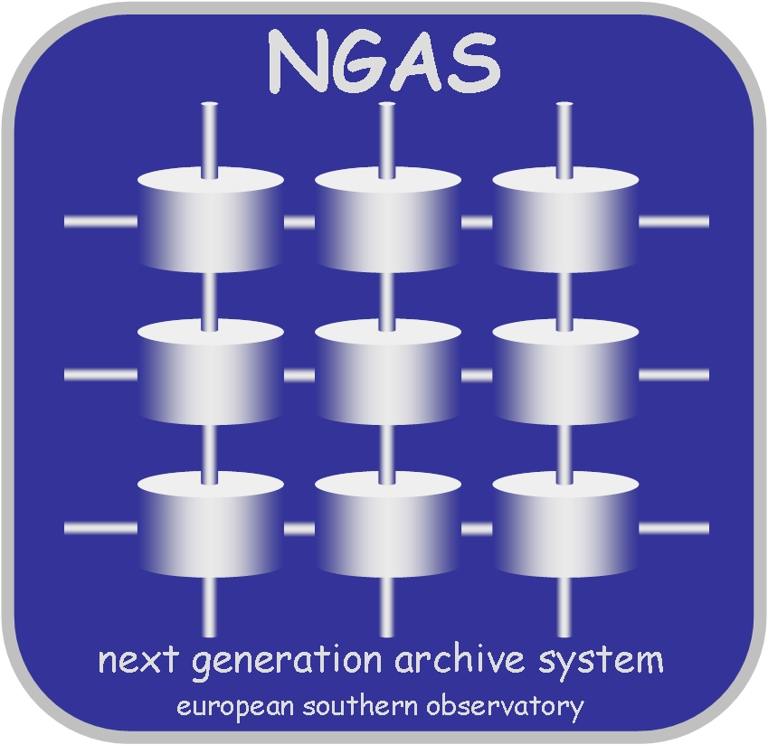 | Internal Memo  NGAS  APEX Archive Environment  Revision 0.1  J. Knudstup, DMD/ESO, 2005-09-13

TOC
TOC 1
Introduction 1
Pre-conditions 1
Ingestion Tool - ngasArchiveFromTree 1
NGAS Archiving Plug-In - ngasApexDapi 2
APEX Disk Handling Procedure 3

Introduction
This document describes the operational environment, implemented to support archiving of APEX data from the USB disks sent to us from the telescope site.

Pre-conditions
The following is assumed for the data handled:

- the filenames found on the USB disks are unique for different files.
- the files are a multiple of 2880.
- the INSTRUME keyword is set to "APEXHET", "APEXBOL" or "APEXTEST".
- the FITS checksum and datasum (CHECKSUM, DATASUM) are properly computed and set in all headers according to the new scheme defined for checksum at ESO.

These checks are pretty much the standard checks carried out by other DAPI’s in use for FITS files.

Ingestion Tool - ngasArchiveFromTree
A small tool will be provided to carry out the actual ingestion of the data in the given location. It will be implemented within the scope of the NGAS Utilities.
The synopsis is as follows:

$ ngasArchiveFromTree --servers=<Server List> --srcDir=<Dir>
--extensions=<Ext 1>[,<Ext 2>]…
[--list] [--archive] [--check] [--cleanup] [--workdir=<Dir>]
[--notifEmail=<Email List>] [--noVersioning]

It will scan the given source directory for files with the given extension and schedule these for archiving.

The tool will be persistent such that if it is interrupted while running, it willl resume from where it was stopped when restarted.

If files found on the disk could not be archived, they will be left in the source location. The issue will be reported in the email notification report sent out by the tool.

The command line parameters are:

Parameter | Default Value | Description
--servers | None | List of NGAS + ports to contact. Must be of the form: “<Node 1>:<Port 1>,…”.
--srcDir | None | The directory which will be traversed looking for files with the given extensions. If the are sub-directories under the given path, these will be scanned as well.
--extensions | None | Comma separated list of extensions to take into account when scanning the given source directory.
--list | False | Generate a list of files, which matches the specified conditions for the file scan.
--archive | False | Archive the files.
--check | False | Carry out a check if the files, which have been registered as archive really are archived.
--cleanup | False | Remove file that have been archived from the source tree. If clean up is requested a check will always be executed before deleting any files.
--workdir | /tmp | Working directory of the tool. In this directory files used for the book keeping will be kept.
--notifEmail | None | If not specified, the value defined in ~/.ngas will be taken. If not specified on the command line or in ~/.ngas, the tool will bail out.
--noVersioning | False | If specified (True) no file versioning will be allocated if a data object gets the same File ID. I.e., all APEX data will get file version 1.

An alias will be provided for the tool to make it easy for the operators to use it. This alias will be named: “ngasUsb2Ngas”.

NGAS Archiving Plug-In - ngasApexDapi
A dedicated DAPI, will be implemented to handle the archiving of APEX files. The plug-in does the following:

- If the file is gzip’ed, create a uncompressed temporary working copy.
- Check if file is a multiple of 2880.
- Execute a checksum check of the file using “chksumVerFitsChecksum”.
- Delete temporary working copy (is done anyway by NG/AMS after the DAPI has executed).
- Invoke Frame Ingest on the file. If the file has already been processed by Frame Ingest, this is ignored and the normal processed carried out by the DAPI.
- Extract information for the NGAS DB from the file.
- Return control to the host application (NG/AMS Server).

The plug-in will be based on the library functions implemented for other plug-ins.

APEX Disk Handling Procedure
The following procedure is applied for handling the archiving of APEX data:

- USB disk received from Chile.
- The disk is inserted in the ingestion unit.
- The ingestion unit is switched on.
- The “ngasUsb2Ngas” command (alias) is invoked by the archive operator.
- When the tool finishes execution, a report is generated which contains a summary of the actions carried out and a complete list of all files processed, the overall status of handling the file and the complete status from NGAS. It is suggested to keep these reports for the record (at least for a while).
- The operator executes the command (alias) “ngasCheckUsb2Ngas”. It carries out a rescan of the USB disk. In case files are found, these are listed. If files are found in the specified tree, the entire contents of the disk has not be processed and it is necessary to return to 4. If some files cannot be archived these are left on the disk. The responsibles for the APEX data should be informed.
- When 6. is OK, the ingestion node can be powered off and the disk removed. Afterwards the disk can be send back to the telescope site.
- At the APEX telescope site the operators should check if the disk is empty. If not, they should look into why. Maybe some files could not be archived if they are ‘bad’.

It is important that the disks are sent back empty, since this is an acknowledgement to the APEX operators in Chile, that the data has been successfully ingested in the archive at HQ. They should be instructed, that if data is found on a disk, they should please cross-check with SAO if the data has been archived.

